CHFA
Capital Needs Assessment and Replacement Reserve Analysis

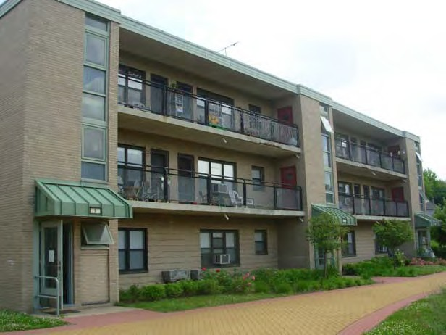Prepared for:

Connecticut Housing Finance Authority
999 West Street Rocky Hill, CT 06067
and

Recap Real Estate Advisors
38 Chauncy Street, Suite 600
Boston, MA 02111

on-site-insight.com
Armstrong Court
CHFA # 85060D
Greenwich Housing Authority Greenwich, CT

July 11, 2013

Final Report

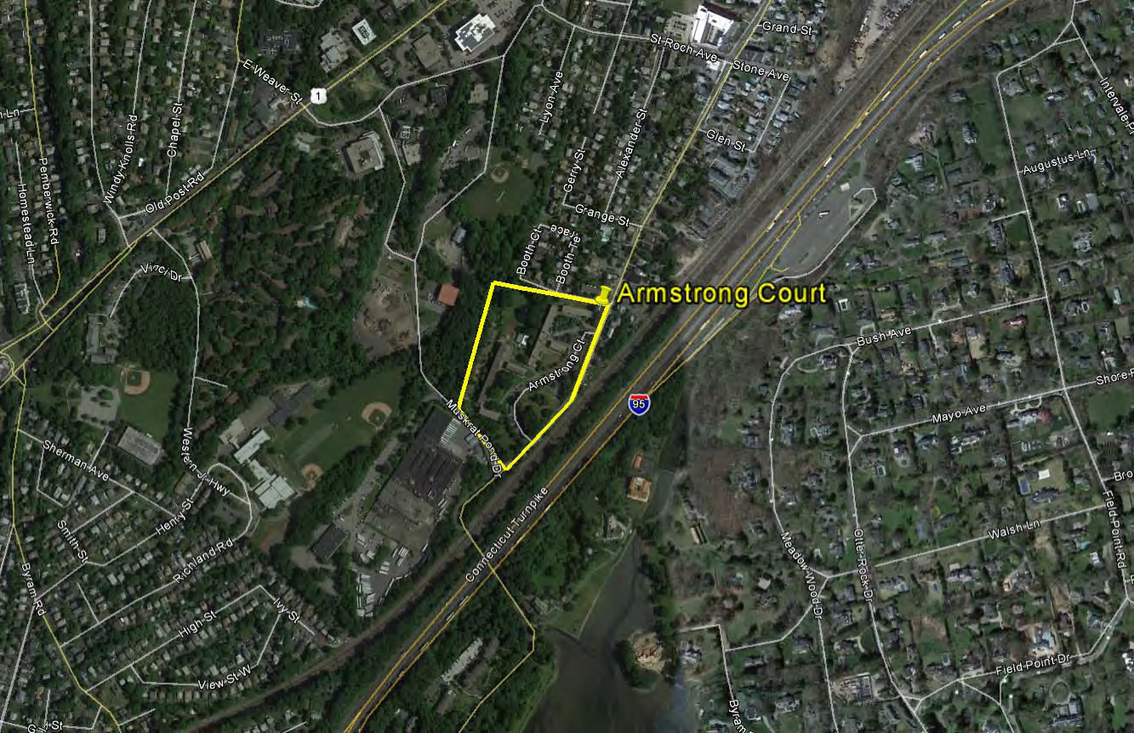

Armstrong Court
1-5 Armstrong Court
Greenwich, CT 06830

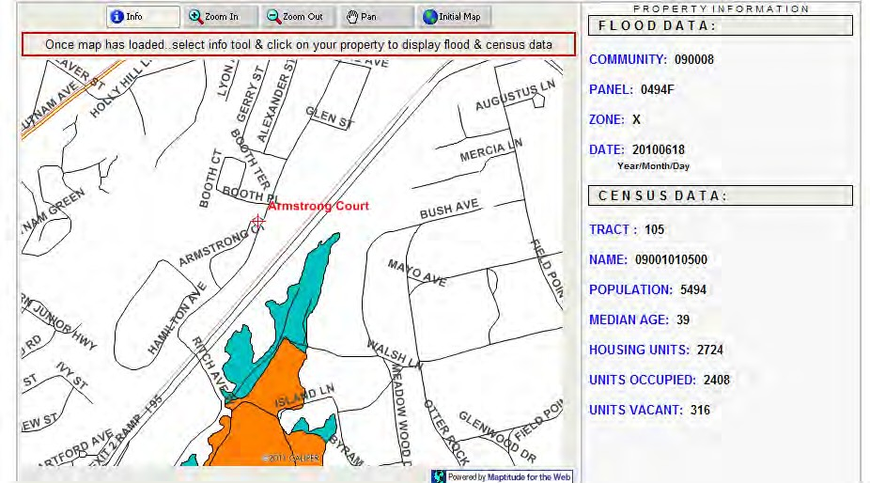

Armstrong Court
1-5 Armstrong Court
Greenwich, CT 06830

Zone X = Outside the 500-year floodplain and
Outside the 1% and 0.2% annual chance floodplains

Executive Summary

Armstrong Court

Greenwich, CT

Armstrong Court is a residential development for families. The development is comprised of 6 residential buildings containing a total of 144 units (12 one-bedroom, 108 two-bedroom, and 24 three-bedroom units). The “First Steps” daycare school building is also located on site, reportedly built in 1999. A separate daycare facility (“Kid’s Corner”) is located at the basement level of one of the residential buildings. Original construction of the development’s residential buildings dates to 1951. There are no handicap accessible units at this property.
Overall the development is in fair to good condition. As shown on the attached capital needs worksheets, the property faces significant capital expenditures over the term of the plan. Greenwich Housing Authority representatives report that there is approximately $291,243 of Reserve Funding in place for this development. Based on projections, the development is seen as requiring an increase of replacement reserve funding and/or an infusion of additional capital.
Key findings identified as part of this assessment include the following:

- The roadways are maintained by the municipality. Parking areas are shown for resurfacing in Years 2 and 3. Periodic repair allowances for retaining walls are shown throughout the plan. Most site walks have recently been resurfaced / replaced. Periodic repair and sealcoating allowances are shown in the plan. Walks and curbing along Armstrong are due to be replaced and upgraded. Costs for this work are shown in Years 2-3. Wood post and rail fencing along these walks is shown being replaced as well. The basketball court is shown for resurfacing work in Year 2. The playground area’s equipment and ground cover are to be replaced / upgraded in 2013. Landscaping is generally maintained from operations. Tree pruning and removal allowances are shown in the plan. Site signage is

shown being updated starting in Year 2 and again in Year 15. Site heating and domestic hot water supply and return lines are original, and site staff noted continual leak concerns. On-site replacement costs are shown in Year 2.
- Building exteriors are primarily clad with brick masonry (EIFS at “First Steps” Daycare). Cracking and mortar deterioration were observed at several locations, and repairs are shown starting in Years 2 and 19. EFIS surfaces outside the daycare building are shown for repair and refinishing in Years 3 and 19. Concrete balconies display spot spalling, and railings are rusting. Concrete repairs and refinishing of railings are included in the plan in Years 1 and 16. Access into the community room and laundry facilities would be enhanced by replacement of entrance door systems (wider). Unit entrance doors, balcony doors, and storm doors are due to be replaced with more energy efficient models, and costs are shown over time for this work. Service doors to mechanical rooms and from balconies into stairways are to be upgraded as well. Most windows are over thirty years in age, and some operation and hardware problems were reported. Drafts are an additional concern as well. Window replacement is shown in Years 2-6. Stairway window systems are shown for future upgrades in Years 15-16. The daycare building’s windows are shown for future replacement in Year 17. Exterior lighting upgrades are shown starting in Years 3 and 19. Standing seam metal roofing at the daycare building should be monitored. Ballasted membrane and rolled asphalt roofing at the residential buildings varies in age. There were no reported leaks, but significant ponding concerns were noted at some roofing sections. Interim repairs are handled from operations. Replacement costs are shown in Years 3-5.
- Interior common areas are limited to the community room (seldom used) and adjoining restrooms, two laundry room facilities, and common stairways. Periodic allowances for painting these facilities are shown in the plan. Flooring upgrades in the community room are also anticipated. Laundry equipment is maintained from a service provider. The community room’s restrooms need to be expanded to meet accessibility requirements. Costs are shown accordingly. The daycare facilities interior finishes are shown being updated twice in the plan. Kitchen spaces and appliances are shown for upgrades accordingly as well.
- Heating boilers and domestic hot water generation equipment are anticipated for replacement in the early years of the plan. Costs are shown accordingly, including replacement of distribution and return piping lines throughout the buildings. Costs are shown pending engineering of the new systems. HVAC equipment serving the daycare facilities is also shown being updated. A fire detection / monitoring master panel system is to also be installed (per Fire Marshal’s requirements), and costs are pending engineering.

  - Unit interior finishes and fixtures are shown being updated over time. Painting is usually performed on unit turnover, from operations. Vinyl tile flooring varies condition, and replacement allowances are shown annually. Bathroom tub re-glazing and ceramic tile surround repairs are anticipated in most years of the plan. Vanities, sinks, wall accessories, medicine cabinets, toilets, and ventilation / exhaust fans are shown being upgraded over time. Kitchen cabinetry displays hard use and deterioration. Replacements are shown starting in Year 2. Refrigerators are the resident’s responsibility. Most ranges are nearing the end of their EUL, and replacements are shown accordingly. Rangehoods may be replaced with combination microwave. Local ring smoke / fire / CO detection devices are replaced as needed. Electrical circuit breaker panels are older models, and replacement is anticipated in the early years of the plan.

Additional Notes:

- The Physical Assessment of the property was conducted on Monday, June 10th, 2013; Tuesday, June 11th, 2013; and Wednesday, June 12th, 2013. Additional information was provided to ON-SITE INSIGHT by site staff and others. OSI was represented on this assignment by Craig Torres. We would like to thank Ms. Sardis Solano; Mr. Terry Mardula; Mr. Joe Derubeis; Mr. Bruno Lacaria, and the site staff for their assistance.

- There were no “drawings” or “blueprints” available for this development. Dimensional information used in this report was procured via field measurements during the assessment of the property and via aerial images of the development utilizing the GoogleMaps website program.

- Cost estimates used in this assessment are based on data from RS Means Facilities and Construction Cost Data. These cost estimates have been applied uniformly across the entire study portfolio to help ensure consistency of future projections. Actual owner and/or site pricing could vary significantly.

- Unless required by fire, safety, or accessibility codes, items are typically shown being replaced in kind and do not include any planned upgrades or potential upgrade opportunities.

- Regular updates of this plan are recommended to ensure careful monitoring of major building systems and to adjust the program to accommodate unanticipated circumstances surrounding the buildings, operations, and/or occupants.

- This report is delivered subject to the conditions on Appendix A, Statement of Delivery.

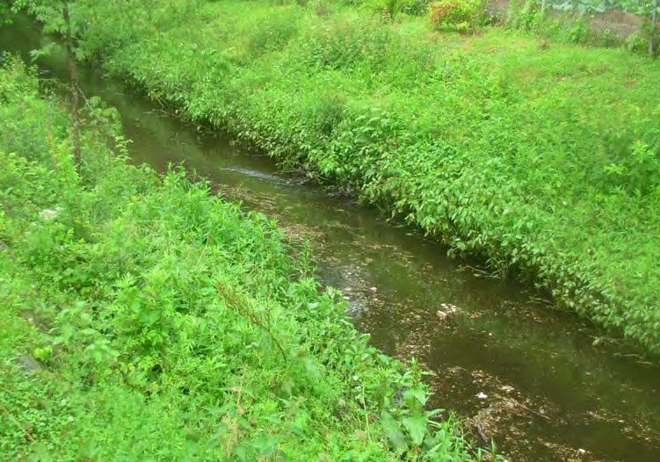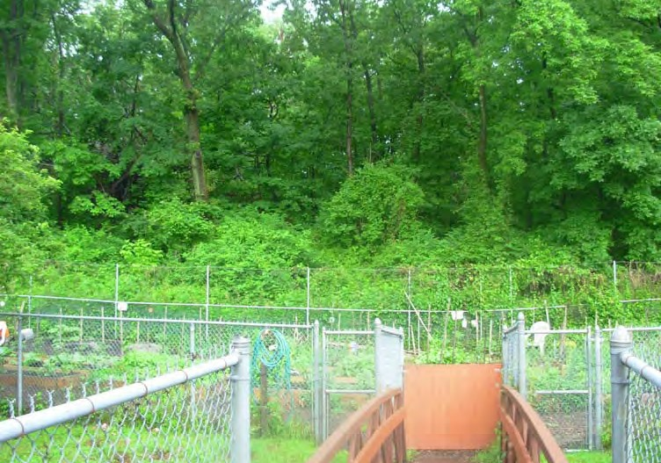
  - River through site to be dredged 2. View of community gardens and associated fencing

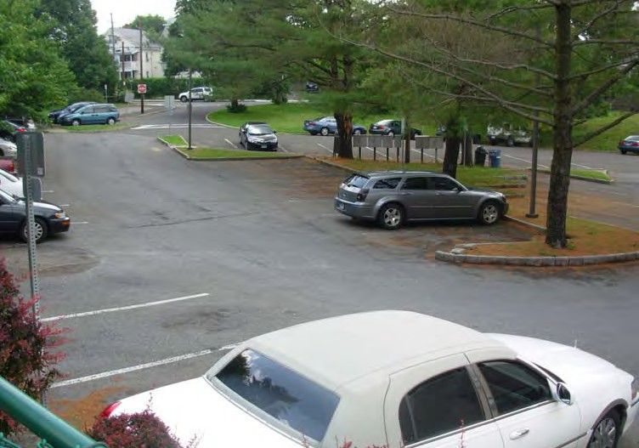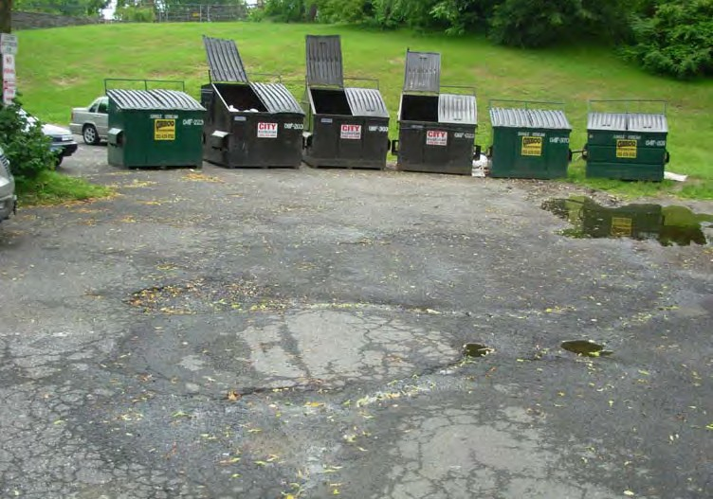
3. Parking area paving 4. Paving at dumpsters, poor conditions

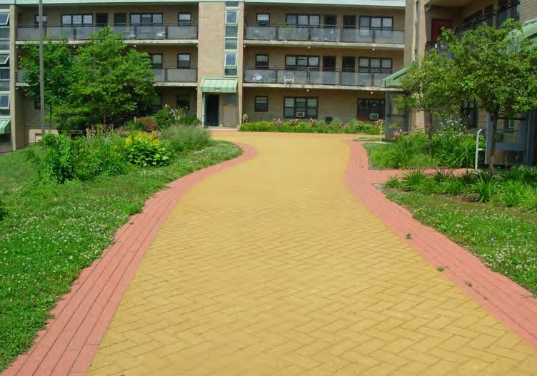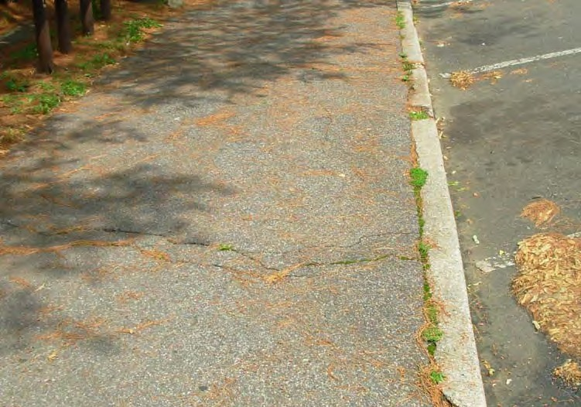
5. Newer site walks, good conditions 6. Walks and curbing along Armstrong

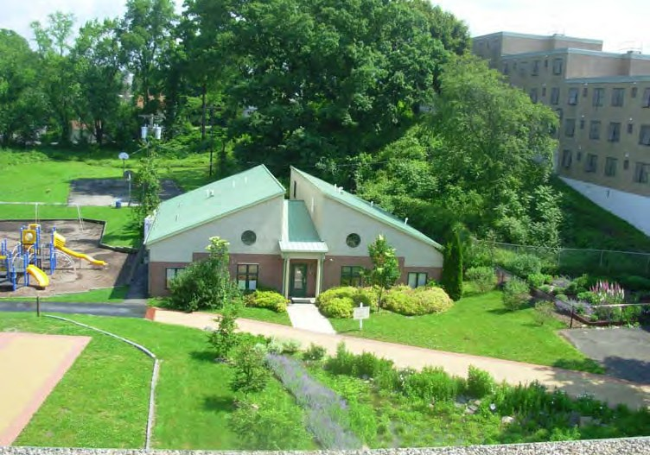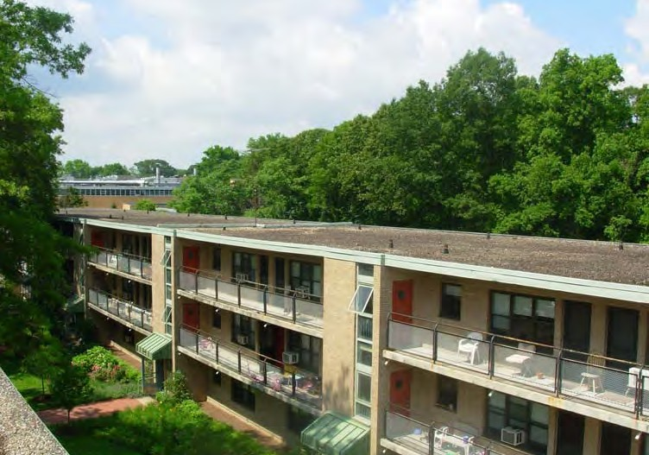
7. View of the First Steps Daycare facility on site 8. Typical building front elevations

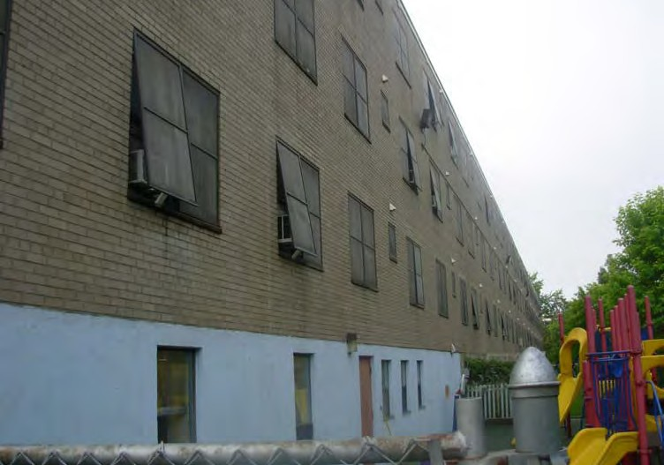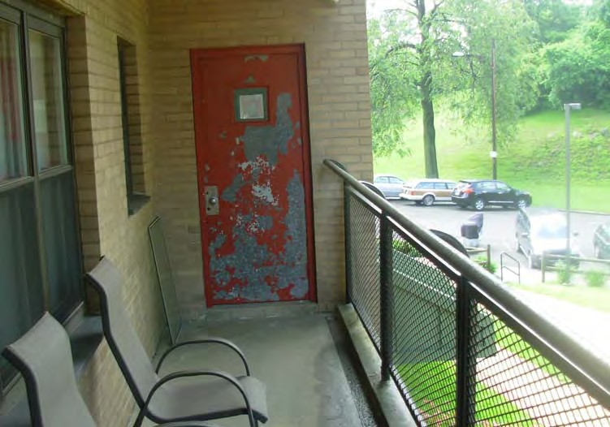
9. Typical building rear elevations 10. Typical balconies and stairway access doors

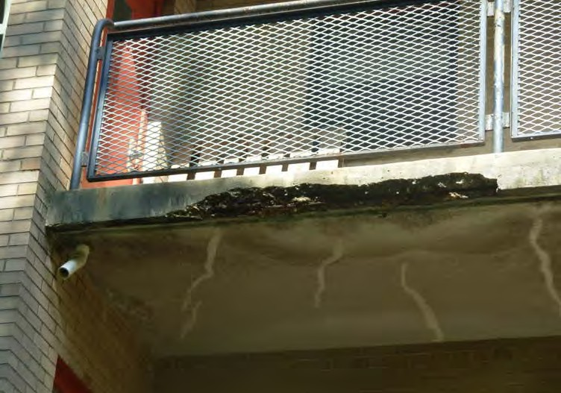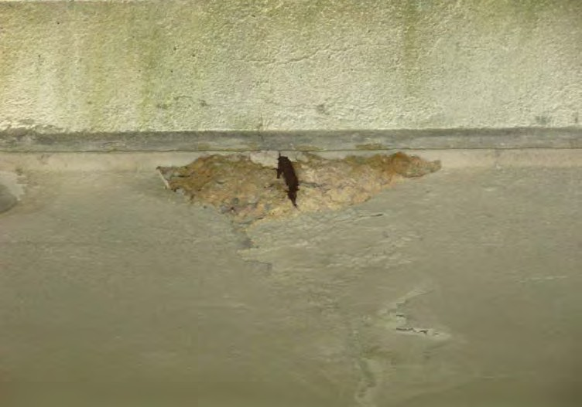
11. Spot spalling of concrete balconies 12. Spot rebar exposure at balconies

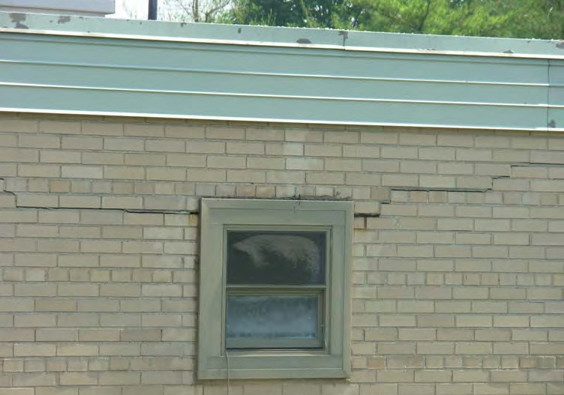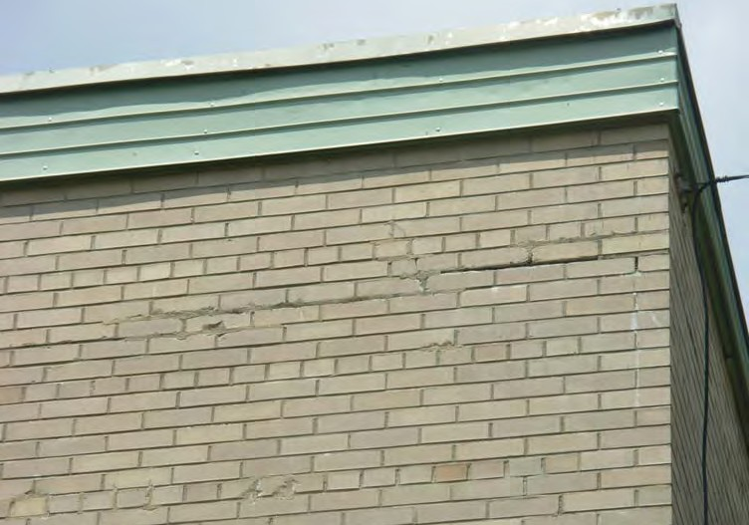
13. Spot masonry cracking and mortar deterioration 14. Spot mortar deterioration, patch repairs done

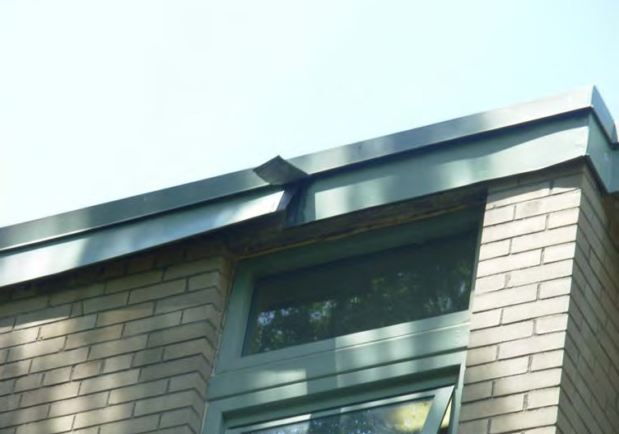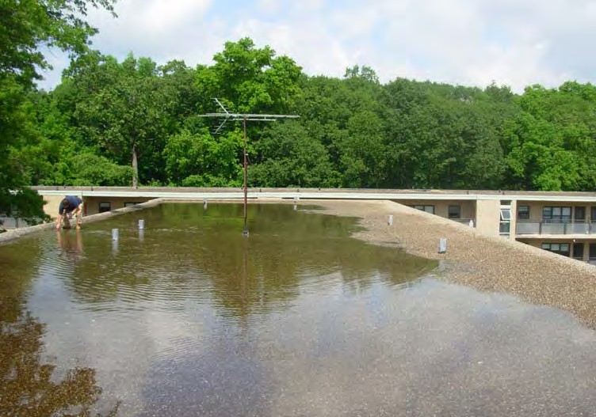
15. Some roofing fascia flashing damage 16. Ponding at one roof surface, due to clogged drains and poor pitch

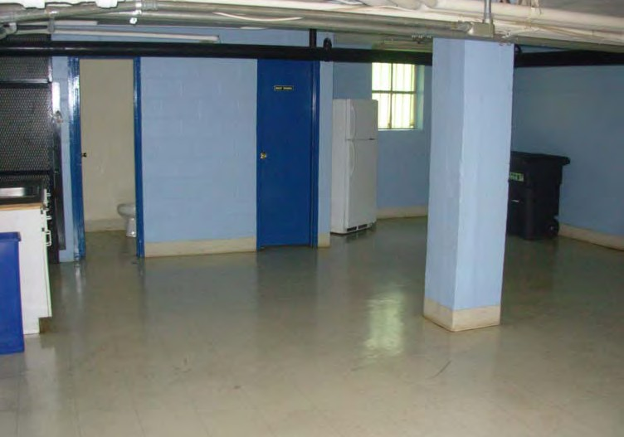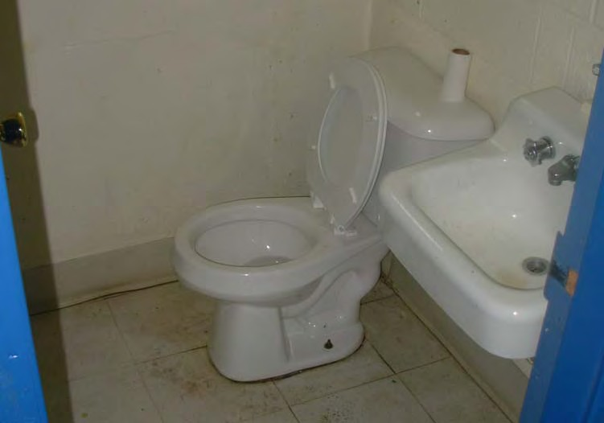
17. Community room finishes, to update 18. Community restrooms to upgrade for accessibility

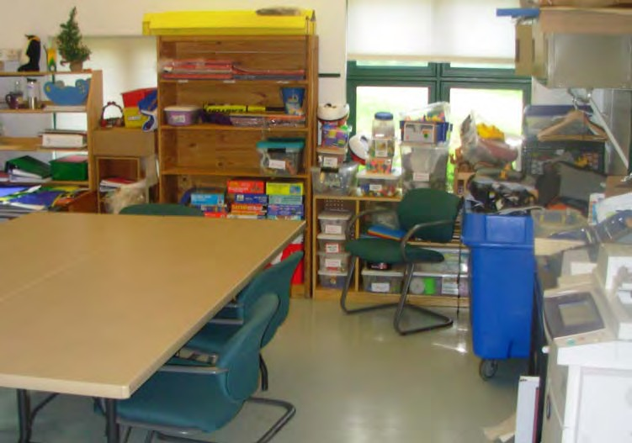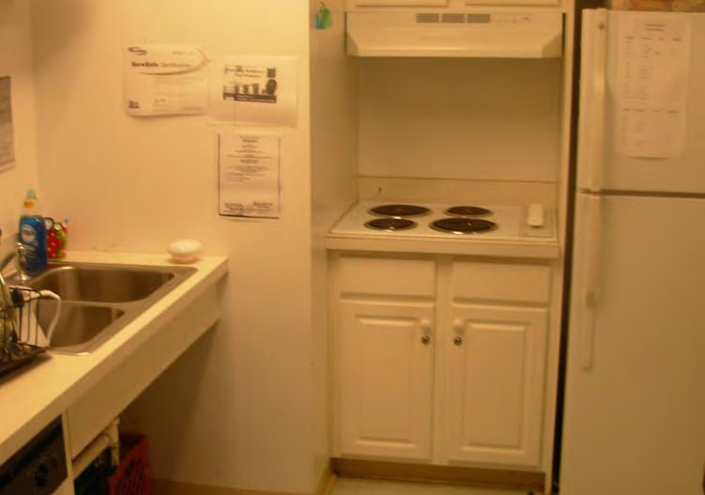
19. First Steps daycare finishes and furnishings 20. Kitchenette serving First Steps daycare to eventually upgrade

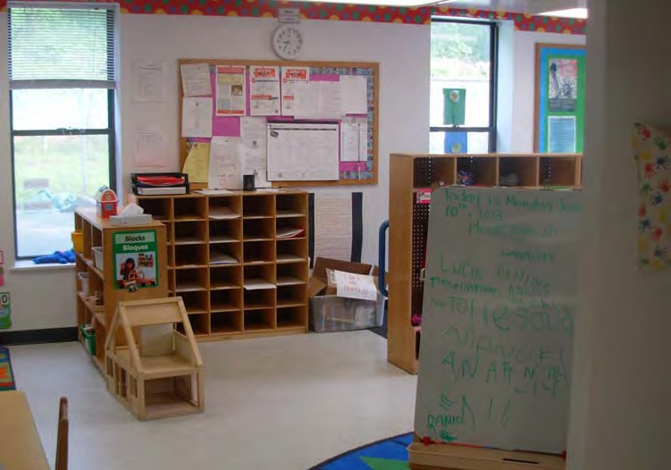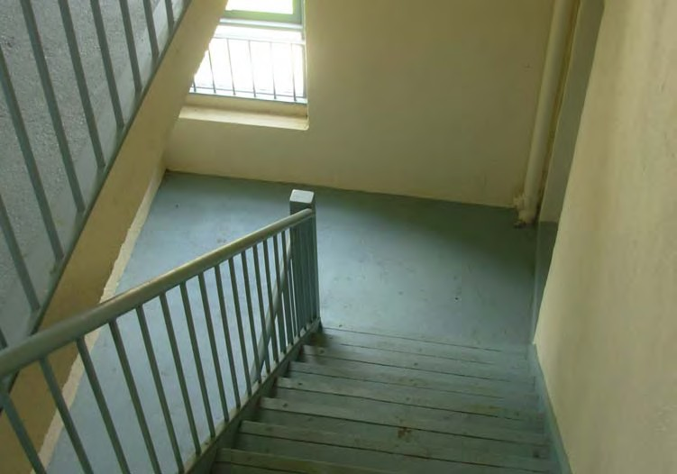
21. Kids Corner daycare facility finishes 22. Typical stairway finishes

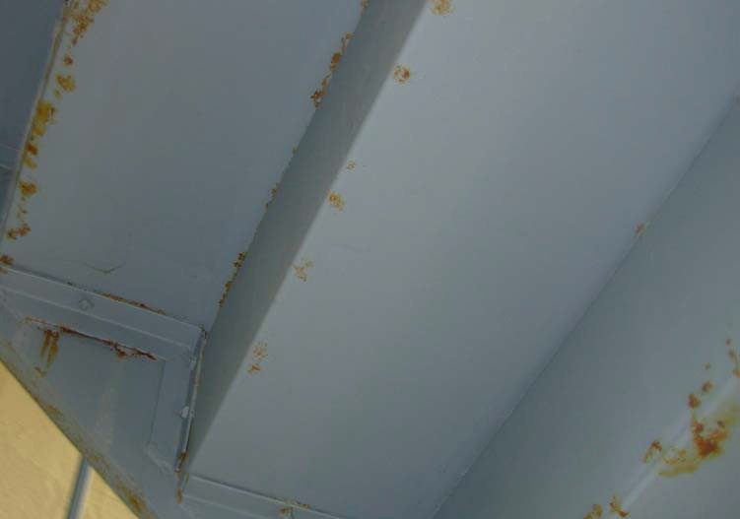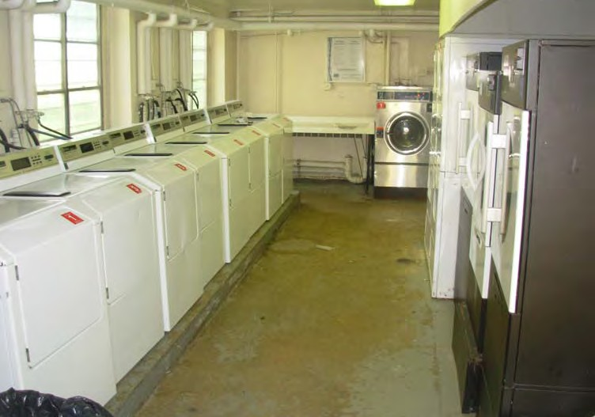
23. Some rusting of stair structures 24. Typical laundry room finishes and equipment

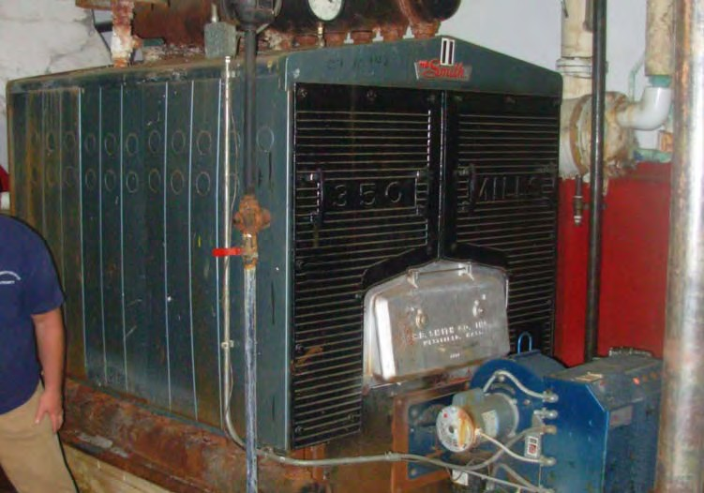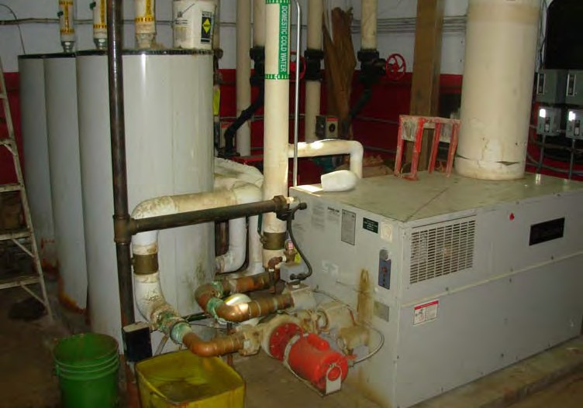
25. Heating plant equipment due to be upgraded 26. DHW equipment to be upgraded

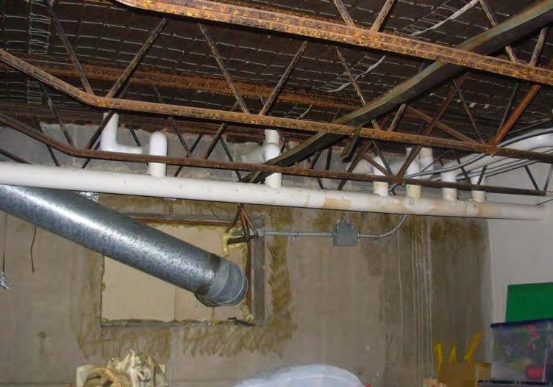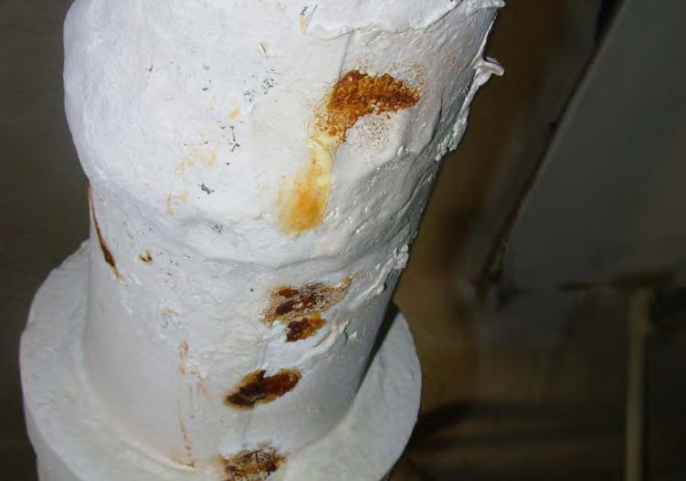
27. Basement-crawl space structure and distribution piping 28. Spot leaks of heating and DHW service line piping

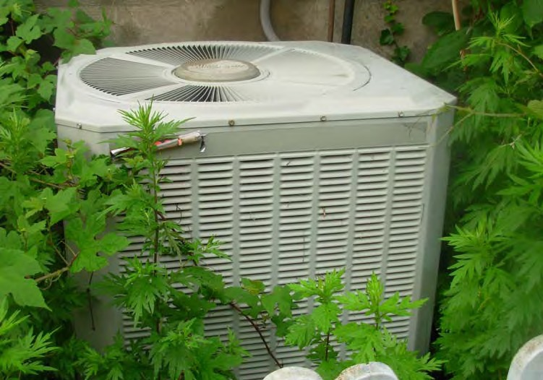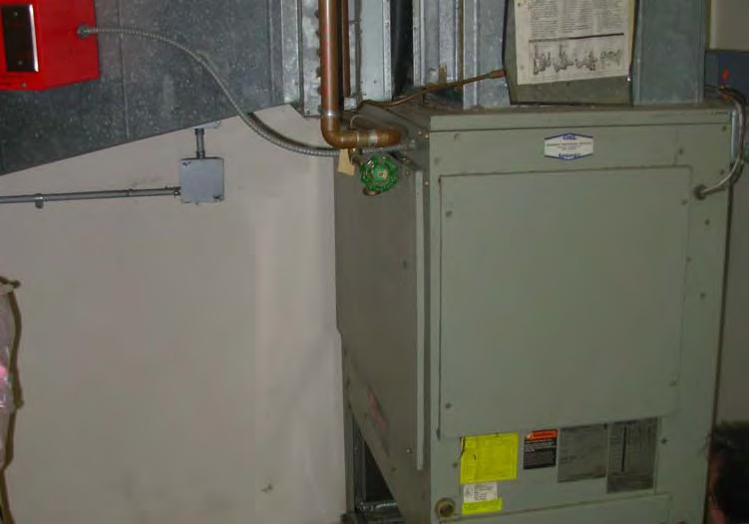
29. AC condenser serving Kids Corner daycare - to replace 30. HVAC equipment serving First Steps daycare

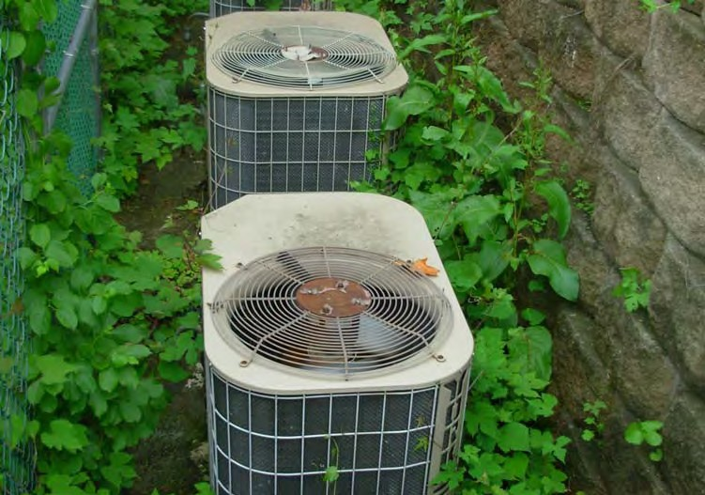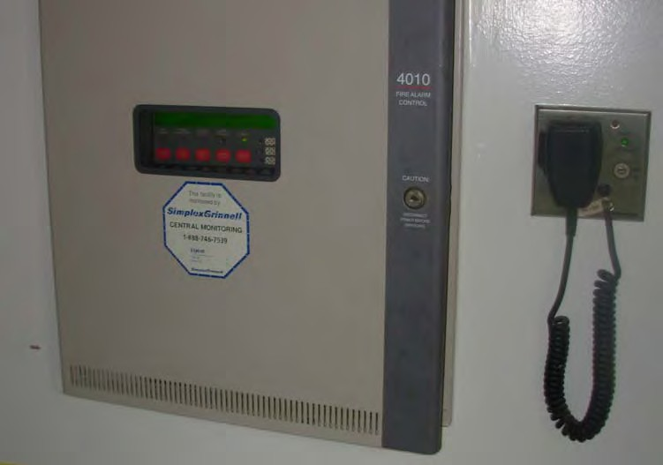

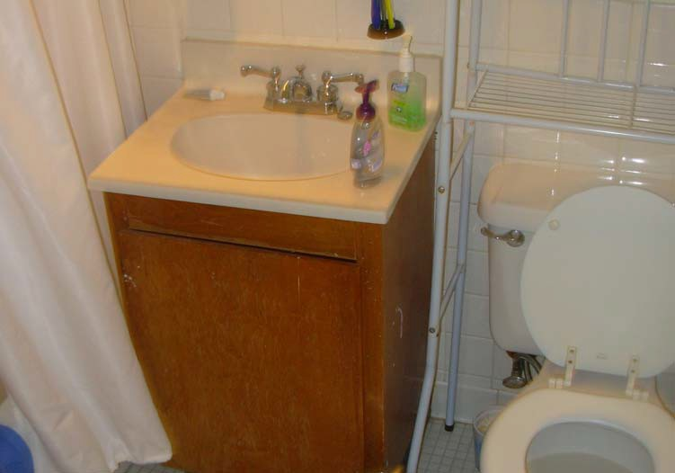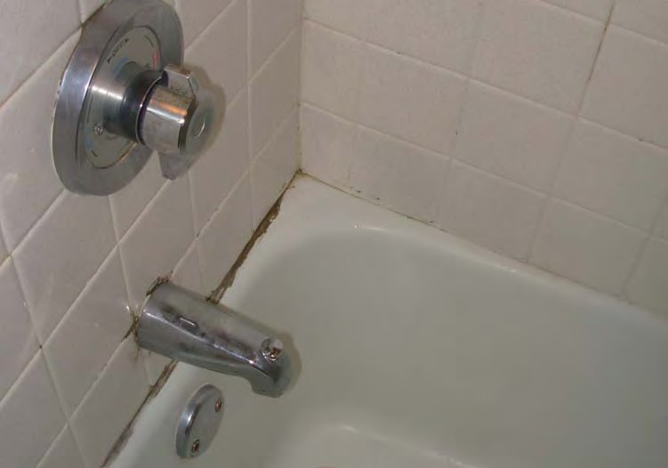
33. Typical unit bath fixtures and finishes 34. Typical unit bath tub and surround conditions

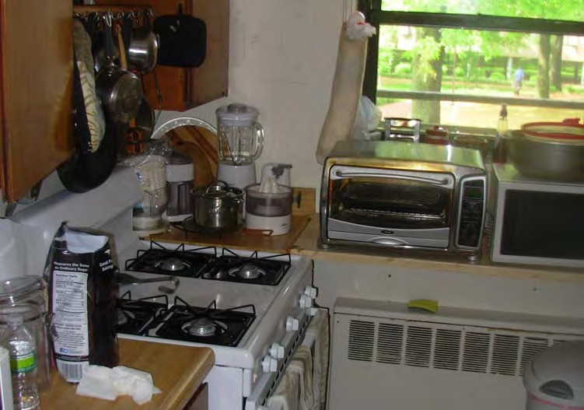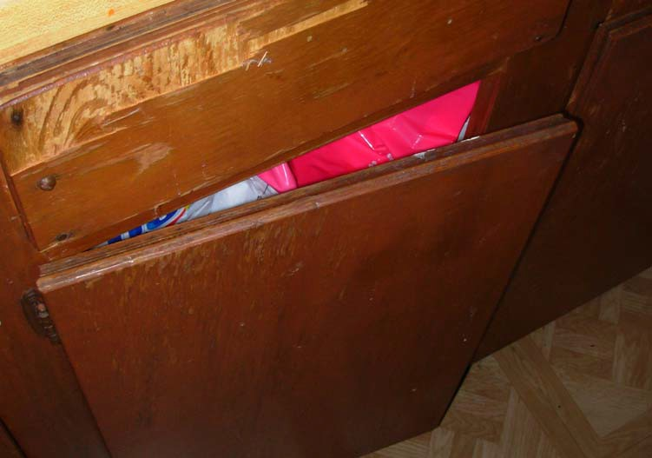

Comprehensive Capital Needs Assessment Schedule Summary
Current Year:
2013
Budget Effective Date:

Report Date:
January 1, 2013

July 11, 2013
Number of Units: 144
Total Square Feet:

Default Inflation Rate:
142,150
3.0%
Owner Sponsor Name: | Greenwich Housing Authority
Project Name: | Armstrong Court
Project City / Town: | Greenwich, CT

Beginning Replacement Reserve Balance: | $291,243
Annual Replacement Reserve Contribution: | $0
Additional Misc. Contribution:

 | Component | Total Planned Expenditures by Year
 |  | Emergency | Deferred | 1 | 2 | 3 | 4 | 5 | 6 | 7 | 8 | 9 | 10 | 11 | 12 | 13 | 14 | 15 | 16 | 17 | 18 | 19 | 20 | Revitalization
 |  |  |  | 2013 | 2014 | 2015 | 2016 | 2017 | 2018 | 2019 | 2020 | 2021 | 2022 | 2023 | 2024 | 2025 | 2026 | 2027 | 2028 | 2029 | 2030 | 2031 | 2032
1 | Site Improvements | 0 | 0 | 127,915 | 530,222 | 157,905 | 45,635 | 11,832 | 11,173 | 20,463 | 5,534 | 22,559 | 16,310 | 47,037 | 0 | 21,235 | 0 | 8,130 | 8,374 | 58,447 | 141,506 | 38,305 | 0 | 0
2 | Building Exterior | 0 10,300 |  | 345,180 | 652,798 | 516,158 | 539,638 | 361,883 | 372,739 | 3,331 | 3,431 | 3,534 | 361,533 | 375,947 | 376,152 | 393,601 | 405,409 | 126,331 | 639,390 | 81,711 | 8,834 | 285,652 | 273,427 | 0
3 | Roofing | 0 | 0 | 0 | 0 | 183,124 | 185,005 | 190,555 | 0 | 0 | 0 | 0 | 0 | 0 | 0 | 0 | 0 | 0 | 0 | 0 | 0 | 5,629 | 0 | 0
4 | Lobby - Mail Area | 0 | 0 | 0 | 0 | 0 | 0 | 0 | 0 | 0 | 0 | 0 | 0 | 0 | 0 | 0 | 0 | 0 | 0 | 0 | 0 | 0 | 0 | 0
5 | Community Room | 0 | 0 | 0 | 9,108 | 7,288 | 9,603 | 13,360 | 25,722 | 3,382 | 3,484 | 0 | 0 | 0 | 7,229 | 4,181 | 4,306 | 2,901 | 7,790 | 18,538 | 0 | 11,525 | 11,871 | 0
6 | Common Hallways | 0 | 0 | 0 | 0 | 0 | 0 | 0 | 0 | 0 | 0 | 0 | 0 | 0 | 0 | 0 | 0 | 0 | 0 | 0 | 0 | 0 | 0 | 0
7 | Common Stairways | 0 | 0 | 0 | 6,180 | 6,365 | 6,556 | 43,395 | 75,128 | 31,344 | 0 | 0 | 0 | 0 | 0 | 0 | 56,621 | 58,319 | 9,348 | 9,628 | 9,917 | 0 | 0 | 0
8 | Common Laundry | 0 | 0 | 0 | 2,803 | 0 | 0 | 0 | 0 | 0 | 3,347 | 0 | 0 | 0 | 0 | 0 | 3,997 | 0 | 0 | 0 | 0 | 0 | 4,773 | 0
9 | Common Area Restrooms | 0 | 20,000 | 20,000 | 0 | 0 | 0 | 0 | 0 | 0 | 0 | 0 | 0 | 0 | 1,353 | 0 | 0 | 0 | 0 | 0 | 0 | 0 | 0 | 0
10 | Building Boilers | 0 | 0 | 0 | 1,571,445 | 0 | 2,322 | 0 | 0 | 0 | 0 | 0 | 0 | 0 | 0 | 0 | 0 | 71,186 | 151,220 | 22,065 | 54,957 | 0 | 0 | 0
11 | Building Mechanical | 0 | 0 | 0 | 10,099 | 10,742 | 11,064 | 0 | 0 | 0 | 0 | 0 | 0 | 0 | 0 | 0 | 0 | 0 | 0 | 0 | 45,831 | 38,587 | 0 | 0
12 | Building Electrical | 0 0 |  | 0 | 172,113 | 10,185 | 10,490 | 15,237 | 20,258 | 11,463 | 0 | 0 | 0 | 0 | 0 | 0 | 0 | 0 | 0 | 0 | 0 | 0 | 0 | 0
13 | Building Elevator | 0 | 0 | 0 | 0 | 0 | 0 | 0 | 0 | 0 | 0 | 0 | 0 | 0 | 0 | 0 | 0 | 0 | 0 | 0 | 0 | 0 | 0 | 0
14 | Building Structural | 0 | 0 | 0 | 0 | 0 | 0 | 0 | 0 | 0 | 0 | 0 | 0 | 0 | 0 | 0 | 0 | 0 | 0 | 0 | 0 | 0 | 0 | 0
15 | Unit Living | 0 | 0 | 36,457 | 37,551 | 38,677 | 39,837 | 41,033 | 42,264 | 43,531 | 44,837 | 46,183 | 47,568 | 48,995 | 50,465 | 51,979 | 53,538 | 55,144 | 56,799 | 58,503 | 60,258 | 62,065 | 63,927 | 0
16 | Unit Kitchens | 0 | 0 | 0 | 167,602 | 189,243 | 194,921 | 200,768 | 18,154 | 0 | 0 | 0 | 0 | 0 | 14,785 | 23,570 | 24,277 | 25,005 | 25,755 | 26,528 | 27,324 | 54,803 | 37,718 | 0
17 | Unit Bathrooms | 0 | 0 | 16,667 | 35,570 | 36,637 | 37,736 | 38,869 | 40,035 | 41,236 | 42,473 | 43,747 | 45,059 | 46,411 | 47,803 | 49,237 | 50,715 | 45,572 | 39,401 | 0 | 0 | 0 | 20,741 | 0
18 | Unit Electrical | 0 | 0 | 0 | 85,034 | 87,585 | 90,212 | 92,919 | 0 | 0 | 22,433 | 23,106 | 23,799 | 0 | 0 | 0 | 0 | 0 | 28,417 | 29,270 | 30,148 | 0 | 0 | 0
19 | Unit Mechanical | 0 | 0 | 0 | 0 | 0 | 0 | 0 | 0 | 0 | 0 | 0 | 0 | 0 | 0 | 0 | 0 | 0 | 0 | 0 | 0 | 0 | 0 | 0
20 | Annual Planned Expenditures | 0 | 30,300 | 546,219 | 3,280,523 | 1,243,910 | 1,173,020 | 1,009,849 | 605,472 | 154,750 | 125,540 | 139,129 | 494,269 | 518,390 | 497,787 | 543,802 | 598,862 | 392,590 | 966,494 | 304,690 | 378,775 | 496,567 | 412,457 | 0
21 | Annual Provision (indexed at 3%) |  |  | 0 | 0 | 0 | 0 | 0 | 0 | 0 | 0 | 0 | 0 | 0 | 0 | 0 | 0 | 0 | 0 | 0 | 0 | 0 | 0
22 | Outside Capital |  |  | 13,766,400
23 | Cumulative Reserve Balance | 291,243 | 260,943 | 13,481,124 | 10,200,601 | 8,956,692 | 7,783,671 | 6,773,822 | 6,168,350 | 6,013,600 | 5,888,060 | 5,748,931 | 5,254,663 | 4,736,272 | 4,238,486 | 3,694,683 | 3,095,821 | 2,703,232 | 1,736,738 | 1,432,049 | 1,053,274 | 556,706 | 144,249

Comprehensive Capital Needs Assessment Schedule Site Improvements

Owner Sponsor Name: | Greenwich Housing Authority
Project Name: | Armstrong Court
Project City / Town: | Greenwich, CT

Current Year: 2013

Budget Effective Date: January 1, 2013

Report Date: July 11, 2013
Number of Units: 144 Total Square Feet: 142,150
Default Inflation Rate: 3.0%

 | Component | Current Total Replacement Cost | Expected Annual Rate of Inflation | Current Age | Total Expected Useful Life | Initial Replacement Year | Planned Expenditures by Year
 |  |  |  |  |  |  | Code | Emergency | Code | Deferred | 1 | 2 | 3 | 4 | 5 | 6 | 7 | 8 | 9 | 10 | 11 | 12 | 13 | 14 | 15 | 16 | 17 | 18 | 19 | 20 | Revitalization
 |  |  |  |  |  |  |  |  |  |  | 2013 | 2014 | 2015 | 2016 | 2017 | 2018 | 2019 | 2020 | 2021 | 2022 | 2023 | 2024 | 2025 | 2026 | 2027 | 2028 | 2029 | 2030 | 2031 | 2032
1 | Asphalt Parking / Roadways |  |  |  |  | 2013 |  |  |  |  | 0 | 0 | 0 | 0 | 0 | 0 | 0 | 0 | 0 | 0 | 0 | 0 | 0 | 0 | 0 | 0 | 0 | 0 | 0 | 0
2 | Crack Fill / Sealant |  |  |  |  | 2013 |  |  |  |  | 0 | 0 | 0 | 0 | 0 | 0 | 0 | 0 | 0 | 0 | 0 | 0 | 0 | 0 | 0 | 0 | 0 | 0 | 0 | 0
3 | Concrete Sidewalks |  |  |  |  | 2013 |  |  |  |  | 0 | 0 | 0 | 0 | 0 | 0 | 0 | 0 | 0 | 0 | 0 | 0 | 0 | 0 | 0 | 0 | 0 | 0 | 0 | 0
4 | Bituminous Sidewalks |  |  |  |  | 2013 |  |  |  |  | 0 | 0 | 0 | 0 | 0 | 0 | 0 | 0 | 0 | 0 | 0 | 0 | 0 | 0 | 0 | 0 | 0 | 0 | 0 | 0
5 | Fencing |  |  |  |  | 2013 |  |  |  |  | 0 | 0 | 0 | 0 | 0 | 0 | 0 | 0 | 0 | 0 | 0 | 0 | 0 | 0 | 0 | 0 | 0 | 0 | 0 | 0
6 | Landscaping |  |  |  |  | 2013 |  |  |  |  | 0 | 0 | 0 | 0 | 0 | 0 | 0 | 0 | 0 | 0 | 0 | 0 | 0 | 0 | 0 | 0 | 0 | 0 | 0 | 0
7 | Dumpster Enclosures |  |  |  |  | 2013 |  |  |  |  | 0 | 0 | 0 | 0 | 0 | 0 | 0 | 0 | 0 | 0 | 0 | 0 | 0 | 0 | 0 | 0 | 0 | 0 | 0 | 0
8 | Storm Water System |  |  |  |  | 2013 |  |  |  |  | 0 | 0 | 0 | 0 | 0 | 0 | 0 | 0 | 0 | 0 | 0 | 0 | 0 | 0 | 0 | 0 | 0 | 0 | 0 | 0
9 | Site Lighting |  |  |  |  | 2013 |  |  |  |  | 0 | 0 | 0 | 0 | 0 | 0 | 0 | 0 | 0 | 0 | 0 | 0 | 0 | 0 | 0 | 0 | 0 | 0 | 0 | 0
10 | Bridges - Repair / Maintain Allowances | 15,000 |  | 12 | 15 | 2016 |  |  |  |  | 0 | 0 | 0 | 16,391 | 0 | 0 | 0 | 0 | 0 | 0 | 0 | 0 | 0 | 0 | 0 | 0 | 0 | 0 | 25,536 | 0
11 | Heating and DHW Supply / Return Lines - to Replace | 366,000 |  | 62 | 63 | 2014 |  |  |  |  | 0 | 376,980 | 0 | 0 | 0 | 0 | 0 | 0 | 0 | 0 | 0 | 0 | 0 | 0 | 0 | 0 | 0 | 0 | 0 | 0
12 | Site Walks (Recent Resurfacing) - repair & seal | 12,500 |  | 5 | 7 | 2015 |  |  |  |  | 0 | 0 | 13,261 | 0 | 0 | 0 | 0 | 0 | 0 | 16,310 | 0 | 0 | 0 | 0 | 0 | 0 | 20,059 | 0 | 0 | 0
13 | River/Stream Dredging / Bank Clearing | 35,000 |  | 62 | 10 | 2013 |  |  |  |  | 35,000 | 0 | 0 | 0 | 0 | 0 | 0 | 0 | 0 | 0 | 47,037 | 0 | 0 | 0 | 0 | 0 | 0 | 0 | 0 | 0
14 | Retaining Walls (Block at Rear of "F.S." Daycare) |  |  | 14 | 40 | 2039 |  |  |  |  | 0 | 0 | 0 | 0 | 0 | 0 | 0 | 0 | 0 | 0 | 0 | 0 | 0 | 0 | 0 | 0 | 0 | 0 | 0 | 0
15 | Retaining Walls (Block and Stone) - Repair Allows. | 7,500 |  | 62 | 6 | 2013 |  |  |  |  | 7,500 | 0 | 0 | 0 | 0 | 0 | 8,955 | 0 | 0 | 0 | 0 | 0 | 10,693 | 0 | 0 | 0 | 0 | 0 | 12,768 | 0
16 | Fencing (Chain Link) - minimal damage - sect. replace allows. | 5,915 |  | 20 | 8 | 2013 |  |  |  |  | 5,915 | 0 | 0 | 0 | 0 | 0 | 0 | 0 | 7,492 | 0 | 0 | 0 | 0 | 0 | 0 | 0 | 9,491 | 0 | 0 | 0
17 | Roadway (Maintained by City) / Parking - Resurface $$ | 55,453 |  | >20 | 20+ | 2014 |  |  |  |  | 0 | 28,558 | 29,415 | 0 | 0 | 0 | 0 | 0 | 0 | 0 | 0 | 0 | 0 | 0 | 0 | 0 | 0 | 0 | 0 | 0
18 | Parking (Repair, Crackfill, Sealcoat, Re-stripe) | 7,394 |  | >10 | 4 | 2021 |  |  |  |  | 0 | 0 | 0 | 0 | 0 | 0 | 0 | 0 | 9,366 | 0 | 0 | 0 | 10,542 | 0 | 0 | 0 | 11,865 | 0 | 0 | 0
19 | Basketball Court (Asphalt) - Resurfacing Costs | 7,938 |  | >20 | 20+ | 2014 |  |  |  |  | 0 | 8,176 | 0 | 0 | 0 | 0 | 0 | 0 | 0 | 0 | 0 | 0 | 0 | 0 | 0 | 0 | 0 | 0 | 0 | 0
20 | Walks & Curbing (along Armstrong) - to replace | 196,000 |  | >20-62 | 30+ | 2014 |  |  |  |  | 0 | 100,940 | 103,968 | 0 | 0 | 0 | 0 | 0 | 0 | 0 | 0 | 0 | 0 | 0 | 0 | 0 | 0 | 0 | 0 | 0
21 | Fencing (Wood Post & Rail) - variable condition - Replace | 19,478 |  | varies | 15+ | 2014 |  |  |  |  | 0 | 10,031 | 10,332 | 0 | 0 | 0 | 0 | 0 | 0 | 0 | 0 | 0 | 0 | 0 | 0 | 0 | 15,628 | 16,097 | 0 | 0
22 | Mail Kiosks - variable ages and conditions - Replace | 16,250 |  | varies | 20+ | 2016 |  |  |  |  | 0 | 0 | 0 | 17,757 | 0 | 0 | 0 | 0 | 0 | 0 | 0 | 0 | 0 | 0 | 0 | 0 | 0 | 0 | 0 | 0
23 | Playground Area / Equipment | 75,000 |  | varies | 15+ | 2013 |  |  |  |  | 75,000 | 0 | 0 | 0 | 0 | 0 | 0 | 0 | 0 | 0 | 0 | 0 | 0 | 0 | 0 | 0 | 0 | 123,964 | 0 | 0
24 | Site Lighting (on-site HIDs) - lighting upgrades to LEDs?? | 38,550 |  | varies | 20+ | 2016 |  |  |  |  | 0 | 0 | 0 | 10,531 | 10,847 | 11,173 | 11,508 | 0 | 0 | 0 | 0 | 0 | 0 | 0 | 0 | 0 | 0 | 0 | 0 | 0
25 | Landscaping / Tree Pruning / Tree Removal | 9,000 |  | varies |  | 2013 |  |  |  |  | 4,500 | 4,635 | 0 | 0 | 0 | 0 | 0 | 5,534 | 5,700 | 0 | 0 | 0 | 0 | 0 | 6,807 | 7,011 | 0 | 0 | 0 | 0
26 | Site Signage (varying signage throughout site) - upgrades | 3,500 |  | varies | 10 | 2020 |  |  |  |  | 0 | 901 | 928 | 956 | 985 | 0 | 0 | 0 | 0 | 0 | 0 | 0 | 0 | 0 | 1,324 | 1,363 | 1,404 | 1,446 | 0 | 0
27 | Annual Planned Expenditures |  |  |  |  |  | 0 |  | 0 |  | 127,915 | 530,222 | 157,905 | 45,635 | 11,832 | 11,173 | 20,463 | 5,534 | 22,559 | 16,310 | 47,037 | 0 | 21,235 | 0 | 8,130 | 8,374 | 58,447 | 141,506 | 38,305 | 0 | 0
28 | Cumulative Reserve Balance |  |  |  |  |  | 291,243 |  | 260,943 |  | 13,481,124 | 10,200,601 | 8,956,692 | 7,783,671 | 6,773,822 | 6,168,350 | 6,013,600 | 5,888,060 | 5,748,931 | 5,254,663 | 4,736,272 | 4,238,486 | 3,694,683 | 3,095,821 | 2,703,232 | 1,736,738 | 1,432,049 | 1,053,274 | 556,706 | 144,249

Comprehensive Capital Needs Assessment Schedule Building Exterior

Owner Sponsor Name: | Greenwich Housing Authority
Project Name: | Armstrong Court
Project City / Town: | Greenwich, CT

Current Year: 2013

Budget Effective Date: January 1, 2013

Report Date: July 11, 2013
Number of Units: 144 Total Square Feet: 142,150
Default Inflation Rate: 3.0%

 | Component | Current Total Replacement Cost | Expected Annual Rate of Inflation | Current Age | Total Expected Useful Life | Initial Replacement Year | Planned Expenditures by Year
 |  |  |  |  |  |  | Code | Emergency | Code | Deferred | 1 | 2 | 3 | 4 | 5 | 6 | 7 | 8 | 9 | 10 | 11 | 12 | 13 | 14 | 15 | 16 | 17 | 18 | 19 | 20 | Revitalization
 |  |  |  |  |  |  |  |  |  |  | 2013 | 2014 | 2015 | 2016 | 2017 | 2018 | 2019 | 2020 | 2021 | 2022 | 2023 | 2024 | 2025 | 2026 | 2027 | 2028 | 2029 | 2030 | 2031 | 2032
1 | Exterior Doors |  |  |  |  | 2013 |  |  |  |  | 0 | 0 | 0 | 0 | 0 | 0 | 0 | 0 | 0 | 0 | 0 | 0 | 0 | 0 | 0 | 0 | 0 | 0 | 0 | 0
2 | Glass Doors (Sliders) |  |  |  |  | 2013 |  |  |  |  | 0 | 0 | 0 | 0 | 0 | 0 | 0 | 0 | 0 | 0 | 0 | 0 | 0 | 0 | 0 | 0 | 0 | 0 | 0 | 0
3 | Exterior Walls - Masonry |  |  |  |  | 2013 |  |  |  |  | 0 | 0 | 0 | 0 | 0 | 0 | 0 | 0 | 0 | 0 | 0 | 0 | 0 | 0 | 0 | 0 | 0 | 0 | 0 | 0
4 | Exterior Walls - EIFS |  |  |  |  | 2013 |  |  |  |  | 0 | 0 | 0 | 0 | 0 | 0 | 0 | 0 | 0 | 0 | 0 | 0 | 0 | 0 | 0 | 0 | 0 | 0 | 0 | 0
5 | Ext. Walls - Vinyl Siding |  |  |  |  | 2013 |  |  |  |  | 0 | 0 | 0 | 0 | 0 | 0 | 0 | 0 | 0 | 0 | 0 | 0 | 0 | 0 | 0 | 0 | 0 | 0 | 0 | 0
6 | Ext. Walls - Wood Siding |  |  |  |  | 2013 |  |  |  |  | 0 | 0 | 0 | 0 | 0 | 0 | 0 | 0 | 0 | 0 | 0 | 0 | 0 | 0 | 0 | 0 | 0 | 0 | 0 | 0
7 | Windows |  |  |  |  | 2013 |  |  |  |  | 0 | 0 | 0 | 0 | 0 | 0 | 0 | 0 | 0 | 0 | 0 | 0 | 0 | 0 | 0 | 0 | 0 | 0 | 0 | 0
8 | Exterior Soffits and Fascia |  |  |  |  | 2013 |  |  |  |  | 0 | 0 | 0 | 0 | 0 | 0 | 0 | 0 | 0 | 0 | 0 | 0 | 0 | 0 | 0 | 0 | 0 | 0 | 0 | 0
9 | Caulking |  |  |  |  | 2013 |  |  |  |  | 0 | 0 | 0 | 0 | 0 | 0 | 0 | 0 | 0 | 0 | 0 | 0 | 0 | 0 | 0 | 0 | 0 | 0 | 0 | 0
10 | Unit Balconies / Decks |  |  |  |  | 2013 |  |  |  |  | 0 | 0 | 0 | 0 | 0 | 0 | 0 | 0 | 0 | 0 | 0 | 0 | 0 | 0 | 0 | 0 | 0 | 0 | 0 | 0
11 | Railings |  |  |  |  | 2013 |  |  |  |  | 0 | 0 | 0 | 0 | 0 | 0 | 0 | 0 | 0 | 0 | 0 | 0 | 0 | 0 | 0 | 0 | 0 | 0 | 0 | 0
12 | Fire Escape / Cat Walks - repair and refinish allowances | 8,000 |  | 29 | 10 | 2013 |  |  |  |  | 8,000 | 0 | 0 | 0 | 0 | 0 | 0 | 0 | 0 | 0 | 10,751 | 0 | 0 | 0 | 0 | 0 | 0 | 0 | 0 | 0
13 | Balconies / Decks & Railings - conc. spalling, railings rusting | 326,880 |  | 62 | 15 | 2013 |  |  |  |  | 326,880 | 0 | 0 | 0 | 0 | 0 | 0 | 0 | 0 | 0 | 0 | 0 | 0 | 0 | 0 | 509,268 | 0 | 0 | 0 | 0
14 | Service Doors (Metal to Mech. Rooms - Stairs to Balcs.) | 156,560 |  | 29 | 30 | 2014 |  |  |  |  | 0 | 161,257 | 0 | 0 | 0 | 0 | 0 | 0 | 0 | 0 | 0 | 0 | 0 | 0 | 0 | 0 | 0 | 0 | 0 | 0
15 | Accessibility Improvements (Doors to Cmnty. & Laundry) | 10,300 |  | 29 | 20 | 2013 |  |  | 4 | 10,300 | 10,300 | 0 | 0 | 0 | 0 | 0 | 0 | 0 | 0 | 0 | 0 | 0 | 0 | 0 | 0 | 0 | 0 | 0 | 0 | 0
16 | Exterior Common Doors (Daycare Fac.) - Upgrades | 19,176 |  | 17 | 20 | 2016 |  |  |  |  | 0 | 0 | 0 | 20,954 | 0 | 0 | 0 | 0 | 0 | 0 | 0 | 0 | 0 | 0 | 0 | 0 | 0 | 0 | 0 | 0
17 | Unit Doors / Storm-Screen Doors (Balcony) - Replace | 156,240 |  | varies | 25+ | 2014 |  |  |  |  | 0 | 32,185 | 33,151 | 34,146 | 35,170 | 36,225 | 0 | 0 | 0 | 0 | 0 | 0 | 0 | 0 | 0 | 0 | 0 | 0 | 0 | 0
18 | Unit Stairway Entrance Doors - Replace / Update over time | 92,700 |  | varies | 20+ | 2014 |  |  |  |  | 0 | 19,096 | 19,669 | 20,259 | 20,867 | 21,493 | 0 | 0 | 0 | 0 | 0 | 0 | 0 | 0 | 0 | 0 | 0 | 0 | 0 | 0
19 | Storm/Screen Doors (future replacements) | 35,568 |  | varies | 10+ | 2025 |  |  |  |  | 0 | 0 | 0 | 0 | 0 | 0 | 0 | 0 | 0 | 0 | 0 | 0 | 10,142 | 10,447 | 10,760 | 11,083 | 11,415 | 0 | 0 | 0
20 | Exterior Walls (Brick) - pointing/repair allowances | 459,424 |  | 14-62 | 15+ | 2014 |  |  |  |  | 0 | 157,736 | 162,468 | 167,342 | 0 | 0 | 0 | 0 | 0 | 0 | 0 | 0 | 0 | 0 | 0 | 0 | 0 | 0 | 260,713 | 268,534
21 | "F.S." Daycare Ext. Walls (EIFS) - Repair / Refinish | 11,859 |  | 14 | 15+ | 2015 |  |  |  |  | 0 | 0 | 12,582 | 0 | 0 | 0 | 0 | 0 | 0 | 0 | 0 | 0 | 0 | 0 | 0 | 0 | 0 | 0 | 20,190 | 0
22 | Exterior Ceilings - Refinishing Allowances | 5,345 |  | 62 | <10 | 2014 |  |  |  |  | 0 | 5,505 | 0 | 0 | 0 | 0 | 0 | 0 | 0 | 6,974 | 0 | 0 | 0 | 0 | 0 | 0 | 0 | 8,834 | 0 | 0
23 | Windows (Alum. D/H) - some operation, hardware problems | 1,344,750 |  | >30 | 30+ | 2014 |  |  |  |  | 0 | 277,019 | 285,329 | 293,889 | 302,706 | 311,787 | 0 | 0 | 0 | 350,919 | 361,446 | 372,290 | 383,458 | 394,962 | 0 | 0 | 0 | 0 | 0 | 0
24 | Windows (Alum. Awning Type) - at Stairways | 152,813 |  | 18 | 30+ | 2027 |  |  |  |  | 0 | 0 | 0 | 0 | 0 | 0 | 0 | 0 | 0 | 0 | 0 | 0 | 0 | 0 | 115,571 | 119,038 | 0 | 0 | 0 | 0
25 | Windows (Alum. Framed) - at "F.S." Daycare | 43,806 |  | 14 | 30+ | 2029 |  |  |  |  | 0 | 0 | 0 | 0 | 0 | 0 | 0 | 0 | 0 | 0 | 0 | 0 | 0 | 0 | 0 | 0 | 70,296 | 0 | 0 | 0
26 | Exterior Lighting (Unit Fixtures) - varying ages, conditions | 27,900 |  | varies | 15+ | 2015 |  |  |  |  | 0 | 0 | 2,960 | 3,049 | 3,140 | 3,234 | 3,331 | 3,431 | 3,534 | 3,640 | 3,750 | 3,862 | 0 | 0 | 0 | 0 | 0 | 0 | 4,750 | 4,892
27 | Annual Planned Expenditures |  |  |  |  |  | 0 |  | 10,300 |  | 345,180 | 652,798 | 516,158 | 539,638 | 361,883 | 372,739 | 3,331 | 3,431 | 3,534 | 361,533 | 375,947 | 376,152 | 393,601 | 405,409 | 126,331 | 639,390 | 81,711 | 8,834 | 285,652 | 273,427 | 0
28 | Cumulative Reserve Balance |  |  |  |  |  | 291,243 |  | 260,943 |  | 13,481,124 | 10,200,601 | 8,956,692 | 7,783,671 | 6,773,822 | 6,168,350 | 6,013,600 | 5,888,060 | 5,748,931 | 5,254,663 | 4,736,272 | 4,238,486 | 3,694,683 | 3,095,821 | 2,703,232 | 1,736,738 | 1,432,049 | 1,053,274 | 556,706 | 144,249

Comprehensive Capital Needs Assessment Schedule Roofing

Owner Sponsor Name: | Greenwich Housing Authority
Project Name: | Armstrong Court
Project City / Town: | Greenwich, CT

Current Year: 2013

Budget Effective Date: January 1, 2013

Report Date: July 11, 2013
Number of Units: 144 Total Square Feet: 142,150
Default Inflation Rate: 3.0%

 | Component | Current Total Replacement Cost | Expected Annual Rate of Inflation | Current Age | Total Expected Useful Life | Initial Replacement Year | Planned Expenditures by Year
 |  |  |  |  |  |  | Code | Emergency | Code | Deferred | 1 | 2 | 3 | 4 | 5 | 6 | 7 | 8 | 9 | 10 | 11 | 12 | 13 | 14 | 15 | 16 | 17 | 18 | 19 | 20 | Revitalization
 |  |  |  |  |  |  |  |  |  |  | 2013 | 2014 | 2015 | 2016 | 2017 | 2018 | 2019 | 2020 | 2021 | 2022 | 2023 | 2024 | 2025 | 2026 | 2027 | 2028 | 2029 | 2030 | 2031 | 2032
1 | Chimney |  |  |  |  | 2013 |  |  |  |  | 0 | 0 | 0 | 0 | 0 | 0 | 0 | 0 | 0 | 0 | 0 | 0 | 0 | 0 | 0 | 0 | 0 | 0 | 0 | 0
2 | Hatches / Skylights |  |  |  |  | 2013 |  |  |  |  | 0 | 0 | 0 | 0 | 0 | 0 | 0 | 0 | 0 | 0 | 0 | 0 | 0 | 0 | 0 | 0 | 0 | 0 | 0 | 0
3 | Penthouse / Machine Rooms |  |  |  |  | 2013 |  |  |  |  | 0 | 0 | 0 | 0 | 0 | 0 | 0 | 0 | 0 | 0 | 0 | 0 | 0 | 0 | 0 | 0 | 0 | 0 | 0 | 0
4 | Roof Railings |  |  |  |  | 2013 |  |  |  |  | 0 | 0 | 0 | 0 | 0 | 0 | 0 | 0 | 0 | 0 | 0 | 0 | 0 | 0 | 0 | 0 | 0 | 0 | 0 | 0
5 | Roof - Asphalt Shingle |  |  |  |  | 2013 |  |  |  |  | 0 | 0 | 0 | 0 | 0 | 0 | 0 | 0 | 0 | 0 | 0 | 0 | 0 | 0 | 0 | 0 | 0 | 0 | 0 | 0
6 | Roof - Built-up Tar and Gravel |  |  |  |  | 2013 |  |  |  |  | 0 | 0 | 0 | 0 | 0 | 0 | 0 | 0 | 0 | 0 | 0 | 0 | 0 | 0 | 0 | 0 | 0 | 0 | 0 | 0
7 | Roof - Single-ply Membrane |  |  |  |  | 2013 |  |  |  |  | 0 | 0 | 0 | 0 | 0 | 0 | 0 | 0 | 0 | 0 | 0 | 0 | 0 | 0 | 0 | 0 | 0 | 0 | 0 | 0
8 | Other |  |  |  |  | 2013 |  |  |  |  | 0 | 0 | 0 | 0 | 0 | 0 | 0 | 0 | 0 | 0 | 0 | 0 | 0 | 0 | 0 | 0 | 0 | 0 | 0 | 0
9 | Other |  |  |  |  | 2013 |  |  |  |  | 0 | 0 | 0 | 0 | 0 | 0 | 0 | 0 | 0 | 0 | 0 | 0 | 0 | 0 | 0 | 0 | 0 | 0 | 0 | 0
10 | Other |  |  |  |  | 2013 |  |  |  |  | 0 | 0 | 0 | 0 | 0 | 0 | 0 | 0 | 0 | 0 | 0 | 0 | 0 | 0 | 0 | 0 | 0 | 0 | 0 | 0
11 | Other |  |  |  |  | 2013 |  |  |  |  | 0 | 0 | 0 | 0 | 0 | 0 | 0 | 0 | 0 | 0 | 0 | 0 | 0 | 0 | 0 | 0 | 0 | 0 | 0 | 0
12 | Other |  |  |  |  | 2013 |  |  |  |  | 0 | 0 | 0 | 0 | 0 | 0 | 0 | 0 | 0 | 0 | 0 | 0 | 0 | 0 | 0 | 0 | 0 | 0 | 0 | 0
13 | Other |  |  |  |  | 2013 |  |  |  |  | 0 | 0 | 0 | 0 | 0 | 0 | 0 | 0 | 0 | 0 | 0 | 0 | 0 | 0 | 0 | 0 | 0 | 0 | 0 | 0
14 | Other |  |  |  |  | 2013 |  |  |  |  | 0 | 0 | 0 | 0 | 0 | 0 | 0 | 0 | 0 | 0 | 0 | 0 | 0 | 0 | 0 | 0 | 0 | 0 | 0 | 0
15 | Other |  |  |  |  | 2013 |  |  |  |  | 0 | 0 | 0 | 0 | 0 | 0 | 0 | 0 | 0 | 0 | 0 | 0 | 0 | 0 | 0 | 0 | 0 | 0 | 0 | 0
16 | Roofing (Standing Seam Metal) - "F.S." Daycare |  |  | 14 | 40 | 2039 |  |  |  |  | 0 | 0 | 0 | 0 | 0 | 0 | 0 | 0 | 0 | 0 | 0 | 0 | 0 | 0 | 0 | 0 | 0 | 0 | 0 | 0
17 | Roof Covering (Ballasted Memb. & Rolled Asphalt) | 507,918 |  | >16 | 20+ | 2015 |  |  |  |  | 0 | 0 | 179,617 | 185,005 | 190,555 | 0 | 0 | 0 | 0 | 0 | 0 | 0 | 0 | 0 | 0 | 0 | 0 | 0 | 0 | 0
18 | Roof Gutters / Downspouts (clean Optg.) - repair/adjust | 3,306 |  | 14 | 15+ | 2015 |  |  |  |  | 0 | 0 | 3,508 | 0 | 0 | 0 | 0 | 0 | 0 | 0 | 0 | 0 | 0 | 0 | 0 | 0 | 0 | 0 | 5,629 | 0
19 | Roof Drainage (Interior) - some clogging - see "Roof" |  |  | >16-62 | 20+ | 2013 |  |  |  |  | 0 | 0 | 0 | 0 | 0 | 0 | 0 | 0 | 0 | 0 | 0 | 0 | 0 | 0 | 0 | 0 | 0 | 0 | 0 | 0
20 | Chimneys (Brick Masonry) - see "Exterior Walls" above |  |  | 62 | 75+ | 2013 |  |  |  |  | 0 | 0 | 0 | 0 | 0 | 0 | 0 | 0 | 0 | 0 | 0 | 0 | 0 | 0 | 0 | 0 | 0 | 0 | 0 | 0
21 | Canopies (S.S. Metal) - at Stair Towers - Monitor |  |  | 18 | 40 | 2013 |  |  |  |  | 0 | 0 | 0 | 0 | 0 | 0 | 0 | 0 | 0 | 0 | 0 | 0 | 0 | 0 | 0 | 0 | 0 | 0 | 0 | 0
22
23
24
25
26
27 | Annual Planned Expenditures |  |  |  |  |  | 0 |  | 0 |  | 0 | 0 | 183,124 | 185,005 | 190,555 | 0 | 0 | 0 | 0 | 0 | 0 | 0 | 0 | 0 | 0 | 0 | 0 | 0 | 5,629 | 0 | 0
28 | Cumulative Reserve Balance |  |  |  |  |  | 291,243 |  | 260,943 |  | 13,481,124 | 10,200,601 | 8,956,692 | 7,783,671 | 6,773,822 | 6,168,350 | 6,013,600 | 5,888,060 | 5,748,931 | 5,254,663 | 4,736,272 | 4,238,486 | 3,694,683 | 3,095,821 | 2,703,232 | 1,736,738 | 1,432,049 | 1,053,274 | 556,706 | 144,249

Comprehensive Capital Needs Assessment Schedule Lobby / Mail Area

Owner Sponsor Name: | Greenwich Housing Authority
Project Name: | Armstrong Court
Project City / Town: | Greenwich, CT

Current Year: 2013

Budget Effective Date: January 1, 2013

Report Date: July 11, 2013
Number of Units: 144 Total Square Feet: 142,150
Default Inflation Rate: 3.0%

 | Component | Current Total Replacement Cost | Expected Annual Rate of Inflation | Current Age | Total Expected Useful Life | Initial Replacement Year | Planned Expenditures by Year
 |  |  |  |  |  |  | Code | Emergency | Code | Deferred | 1 | 2 | 3 | 4 | 5 | 6 | 7 | 8 | 9 | 10 | 11 | 12 | 13 | 14 | 15 | 16 | 17 | 18 | 19 | 20 | Revitalization
 |  |  |  |  |  |  |  |  |  |  | 2013 | 2014 | 2015 | 2016 | 2017 | 2018 | 2019 | 2020 | 2021 | 2022 | 2023 | 2024 | 2025 | 2026 | 2027 | 2028 | 2029 | 2030 | 2031 | 2032
1 | Walls |  |  |  |  | 2013 |  |  |  |  | 0 | 0 | 0 | 0 | 0 | 0 | 0 | 0 | 0 | 0 | 0 | 0 | 0 | 0 | 0 | 0 | 0 | 0 | 0 | 0
2 | Ceilings |  |  |  |  | 2013 |  |  |  |  | 0 | 0 | 0 | 0 | 0 | 0 | 0 | 0 | 0 | 0 | 0 | 0 | 0 | 0 | 0 | 0 | 0 | 0 | 0 | 0
3 | Floors |  |  |  |  | 2013 |  |  |  |  | 0 | 0 | 0 | 0 | 0 | 0 | 0 | 0 | 0 | 0 | 0 | 0 | 0 | 0 | 0 | 0 | 0 | 0 | 0 | 0
4 | Mail Facilities |  |  |  |  | 2013 |  |  |  |  | 0 | 0 | 0 | 0 | 0 | 0 | 0 | 0 | 0 | 0 | 0 | 0 | 0 | 0 | 0 | 0 | 0 | 0 | 0 | 0
5 | Other |  |  |  |  | 2013 |  |  |  |  | 0 | 0 | 0 | 0 | 0 | 0 | 0 | 0 | 0 | 0 | 0 | 0 | 0 | 0 | 0 | 0 | 0 | 0 | 0 | 0
6 | Other |  |  |  |  | 2013 |  |  |  |  | 0 | 0 | 0 | 0 | 0 | 0 | 0 | 0 | 0 | 0 | 0 | 0 | 0 | 0 | 0 | 0 | 0 | 0 | 0 | 0
7 | Other |  |  |  |  | 2013 |  |  |  |  | 0 | 0 | 0 | 0 | 0 | 0 | 0 | 0 | 0 | 0 | 0 | 0 | 0 | 0 | 0 | 0 | 0 | 0 | 0 | 0
8 | Other |  |  |  |  | 2013 |  |  |  |  | 0 | 0 | 0 | 0 | 0 | 0 | 0 | 0 | 0 | 0 | 0 | 0 | 0 | 0 | 0 | 0 | 0 | 0 | 0 | 0
9 | Other |  |  |  |  | 2013 |  |  |  |  | 0 | 0 | 0 | 0 | 0 | 0 | 0 | 0 | 0 | 0 | 0 | 0 | 0 | 0 | 0 | 0 | 0 | 0 | 0 | 0
10 | Other |  |  |  |  | 2013 |  |  |  |  | 0 | 0 | 0 | 0 | 0 | 0 | 0 | 0 | 0 | 0 | 0 | 0 | 0 | 0 | 0 | 0 | 0 | 0 | 0 | 0
11 | Other |  |  |  |  | 2013 |  |  |  |  | 0 | 0 | 0 | 0 | 0 | 0 | 0 | 0 | 0 | 0 | 0 | 0 | 0 | 0 | 0 | 0 | 0 | 0 | 0 | 0
12 | Other |  |  |  |  | 2013 |  |  |  |  | 0 | 0 | 0 | 0 | 0 | 0 | 0 | 0 | 0 | 0 | 0 | 0 | 0 | 0 | 0 | 0 | 0 | 0 | 0 | 0
13 | Other |  |  |  |  | 2013 |  |  |  |  | 0 | 0 | 0 | 0 | 0 | 0 | 0 | 0 | 0 | 0 | 0 | 0 | 0 | 0 | 0 | 0 | 0 | 0 | 0 | 0
14 | Other |  |  |  |  | 2013 |  |  |  |  | 0 | 0 | 0 | 0 | 0 | 0 | 0 | 0 | 0 | 0 | 0 | 0 | 0 | 0 | 0 | 0 | 0 | 0 | 0 | 0
15 | Other |  |  |  |  | 2013 |  |  |  |  | 0 | 0 | 0 | 0 | 0 | 0 | 0 | 0 | 0 | 0 | 0 | 0 | 0 | 0 | 0 | 0 | 0 | 0 | 0 | 0
16 | Other |  |  |  |  | 2013 |  |  |  |  | 0 | 0 | 0 | 0 | 0 | 0 | 0 | 0 | 0 | 0 | 0 | 0 | 0 | 0 | 0 | 0 | 0 | 0 | 0 | 0
17
18
19
20
21
22
23
24
25
26
27 | Annual Planned Expenditures |  |  |  |  |  | 0 |  | 0 |  | 0 | 0 | 0 | 0 | 0 | 0 | 0 | 0 | 0 | 0 | 0 | 0 | 0 | 0 | 0 | 0 | 0 | 0 | 0 | 0 | 0
28 | Cumulative Reserve Balance |  |  |  |  |  | 291,243 |  | 260,943 |  | 13,481,124 | 10,200,601 | 8,956,692 | 7,783,671 | 6,773,822 | 6,168,350 | 6,013,600 | 5,888,060 | 5,748,931 | 5,254,663 | 4,736,272 | 4,238,486 | 3,694,683 | 3,095,821 | 2,703,232 | 1,736,738 | 1,432,049 | 1,053,274 | 556,706 | 144,249

Comprehensive Capital Needs Assessment Schedule Community Room

Owner Sponsor Name: | Greenwich Housing Authority
Project Name: | Armstrong Court
Project City / Town: | Greenwich, CT

Current Year: 2013

Budget Effective Date: January 1, 2013

Report Date: July 11, 2013
Number of Units: 144 Total Square Feet: 142,150
Default Inflation Rate: 3.0%

 | Component | Current Total Replacement Cost | Expected Annual Rate of Inflation | Current Age | Total Expected Useful Life | Initial Replacement Year | Planned Expenditures by Year
 |  |  |  |  |  |  | Code | Emergency | Code | Deferred | 1 | 2 | 3 | 4 | 5 | 6 | 7 | 8 | 9 | 10 | 11 | 12 | 13 | 14 | 15 | 16 | 17 | 18 | 19 | 20 | Revitalization
 |  |  |  |  |  |  |  |  |  |  | 2013 | 2014 | 2015 | 2016 | 2017 | 2018 | 2019 | 2020 | 2021 | 2022 | 2023 | 2024 | 2025 | 2026 | 2027 | 2028 | 2029 | 2030 | 2031 | 2032
1 | Floor |  |  |  |  | 2013 |  |  |  |  | 0 | 0 | 0 | 0 | 0 | 0 | 0 | 0 | 0 | 0 | 0 | 0 | 0 | 0 | 0 | 0 | 0 | 0 | 0 | 0
2 | Kitchen Cabinets / Sink |  |  |  |  | 2013 |  |  |  |  | 0 | 0 | 0 | 0 | 0 | 0 | 0 | 0 | 0 | 0 | 0 | 0 | 0 | 0 | 0 | 0 | 0 | 0 | 0 | 0
3 | Kitchen Appliances |  |  |  |  | 2013 |  |  |  |  | 0 | 0 | 0 | 0 | 0 | 0 | 0 | 0 | 0 | 0 | 0 | 0 | 0 | 0 | 0 | 0 | 0 | 0 | 0 | 0
4 | Furnishings |  |  |  |  | 2013 |  |  |  |  | 0 | 0 | 0 | 0 | 0 | 0 | 0 | 0 | 0 | 0 | 0 | 0 | 0 | 0 | 0 | 0 | 0 | 0 | 0 | 0
5 | Other |  |  |  |  | 2013 |  |  |  |  | 0 | 0 | 0 | 0 | 0 | 0 | 0 | 0 | 0 | 0 | 0 | 0 | 0 | 0 | 0 | 0 | 0 | 0 | 0 | 0
6 | Other |  |  |  |  | 2013 |  |  |  |  | 0 | 0 | 0 | 0 | 0 | 0 | 0 | 0 | 0 | 0 | 0 | 0 | 0 | 0 | 0 | 0 | 0 | 0 | 0 | 0
7 | Other |  |  |  |  | 2013 |  |  |  |  | 0 | 0 | 0 | 0 | 0 | 0 | 0 | 0 | 0 | 0 | 0 | 0 | 0 | 0 | 0 | 0 | 0 | 0 | 0 | 0
8 | Other |  |  |  |  | 2013 |  |  |  |  | 0 | 0 | 0 | 0 | 0 | 0 | 0 | 0 | 0 | 0 | 0 | 0 | 0 | 0 | 0 | 0 | 0 | 0 | 0 | 0
9 | Other |  |  |  |  | 2013 |  |  |  |  | 0 | 0 | 0 | 0 | 0 | 0 | 0 | 0 | 0 | 0 | 0 | 0 | 0 | 0 | 0 | 0 | 0 | 0 | 0 | 0
10 | Other |  |  |  |  | 2013 |  |  |  |  | 0 | 0 | 0 | 0 | 0 | 0 | 0 | 0 | 0 | 0 | 0 | 0 | 0 | 0 | 0 | 0 | 0 | 0 | 0 | 0
11 | Other |  |  |  |  | 2013 |  |  |  |  | 0 | 0 | 0 | 0 | 0 | 0 | 0 | 0 | 0 | 0 | 0 | 0 | 0 | 0 | 0 | 0 | 0 | 0 | 0 | 0
12 | Other |  |  |  |  | 2013 |  |  |  |  | 0 | 0 | 0 | 0 | 0 | 0 | 0 | 0 | 0 | 0 | 0 | 0 | 0 | 0 | 0 | 0 | 0 | 0 | 0 | 0
13 | Other |  |  |  |  | 2013 |  |  |  |  | 0 | 0 | 0 | 0 | 0 | 0 | 0 | 0 | 0 | 0 | 0 | 0 | 0 | 0 | 0 | 0 | 0 | 0 | 0 | 0
14 | Other |  |  |  |  | 2013 |  |  |  |  | 0 | 0 | 0 | 0 | 0 | 0 | 0 | 0 | 0 | 0 | 0 | 0 | 0 | 0 | 0 | 0 | 0 | 0 | 0 | 0
15 | Other |  |  |  |  | 2013 |  |  |  |  | 0 | 0 | 0 | 0 | 0 | 0 | 0 | 0 | 0 | 0 | 0 | 0 | 0 | 0 | 0 | 0 | 0 | 0 | 0 | 0
16 | Other |  |  |  |  | 2013 |  |  |  |  | 0 | 0 | 0 | 0 | 0 | 0 | 0 | 0 | 0 | 0 | 0 | 0 | 0 | 0 | 0 | 0 | 0 | 0 | 0 | 0
17 | Walls / Ceilings (Refinishing Costs) | 2,290 |  | varies | 10 | 2014 |  |  |  |  | 0 | 2,358 | 0 | 0 | 0 | 0 | 0 | 0 | 0 | 0 | 0 | 3,170 | 0 | 0 | 0 | 0 | 0 | 0 | 0 | 0
18 | Floors (Vinyl Tile) - some seam separation - Replace | 6,553 |  | >20 | 15 | 2014 |  |  |  |  | 0 | 6,749 | 0 | 0 | 0 | 0 | 0 | 0 | 0 | 0 | 0 | 0 | 0 | 0 | 0 | 0 | 10,515 | 0 | 0 | 0
19 | Furnishings (Tables & Chairs) - maintained - Optg. |  |  | varies | 10 | 2013 |  |  |  |  | 0 | 0 | 0 | 0 | 0 | 0 | 0 | 0 | 0 | 0 | 0 | 0 | 0 | 0 | 0 | 0 | 0 | 0 | 0 | 0
20 | "F.S. Daycare" - Walls / Ceilings (Refinishing Costs) | 7,673 |  | varies | <10 | 2015 |  |  |  |  | 0 | 0 | 2,035 | 4,192 | 2,159 | 2,224 | 0 | 0 | 0 | 0 | 0 | 2,655 | 2,735 | 2,817 | 2,901 | 0 | 0 | 0 | 0 | 0
21 | "F.S. Daycare" - Floors (VCT Replc.) (C.Tile in Baths Optg.) | 15,750 |  | 14 | 15+ | 2015 |  |  |  |  | 0 | 0 | 4,177 | 4,303 | 4,432 | 4,565 | 0 | 0 | 0 | 0 | 0 | 0 | 0 | 0 | 0 | 0 | 0 | 0 | 6,703 | 6,904
22 | "F.S. Daycare" - Kitchen - Upgrades | 8,500 |  | 14 | 20 | 2018 |  |  |  |  | 0 | 0 | 0 | 0 | 0 | 9,854 | 0 | 0 | 0 | 0 | 0 | 0 | 0 | 0 | 0 | 0 | 0 | 0 | 0 | 0
23 | "F.S. Daycare" - Furnishings & Equipment - maint. Optg. |  |  | varies | 10 | 2013 |  |  |  |  | 0 | 0 | 0 | 0 | 0 | 0 | 0 | 0 | 0 | 0 | 0 | 0 | 0 | 0 | 0 | 0 | 0 | 0 | 0 | 0
24 | "Kid's Corner Daycare" - Walls / Ceilings (Refinishing Costs) | 3,043 |  | varies | <10 | 2015 |  |  |  |  | 0 | 0 | 1,076 | 1,108 | 1,142 | 0 | 0 | 0 | 0 | 0 | 0 | 1,404 | 1,446 | 1,489 | 0 | 0 | 0 | 0 | 0 | 0
25 | "Kid's Corner Daycare" - Floors (VCT & Carpet) - Upgrades | 8,498 |  | varies | 10+ | 2018 |  |  |  |  | 0 | 0 | 0 | 0 | 0 | 3,284 | 3,382 | 3,484 | 0 | 0 | 0 | 0 | 0 | 0 | 0 | 0 | 0 | 0 | 4,822 | 4,967
26 | "Kid's Corner Daycare" - Kitchen  / Appliances / Furnish. | 10,000 |  | varies | 10+ | 2017 |  |  |  |  | 0 | 0 | 0 | 0 | 5,628 | 5,796 | 0 | 0 | 0 | 0 | 0 | 0 | 0 | 0 | 0 | 7,790 | 8,024 | 0 | 0 | 0
27 | Annual Planned Expenditures |  |  |  |  |  | 0 |  | 0 |  | 0 | 9,108 | 7,288 | 9,603 | 13,360 | 25,722 | 3,382 | 3,484 | 0 | 0 | 0 | 7,229 | 4,181 | 4,306 | 2,901 | 7,790 | 18,538 | 0 | 11,525 | 11,871 | 0
28 | Cumulative Reserve Balance |  |  |  |  |  | 291,243 |  | 260,943 |  | 13,481,124 | 10,200,601 | 8,956,692 | 7,783,671 | 6,773,822 | 6,168,350 | 6,013,600 | 5,888,060 | 5,748,931 | 5,254,663 | 4,736,272 | 4,238,486 | 3,694,683 | 3,095,821 | 2,703,232 | 1,736,738 | 1,432,049 | 1,053,274 | 556,706 | 144,249

Comprehensive Capital Needs Assessment Schedule Common Hallways

Owner Sponsor Name: | Greenwich Housing Authority
Project Name: | Armstrong Court
Project City / Town: | Greenwich, CT

Current Year: 2013

Budget Effective Date: January 1, 2013

Report Date: July 11, 2013
Number of Units: 144 Total Square Feet: 142,150
Default Inflation Rate: 3.0%

 | Component | Current Total Replacement Cost | Expected Annual Rate of Inflation | Current Age | Total Expected Useful Life | Initial Replacement Year | Planned Expenditures by Year
 |  |  |  |  |  |  | Code | Emergency | Code | Deferred | 1 | 2 | 3 | 4 | 5 | 6 | 7 | 8 | 9 | 10 | 11 | 12 | 13 | 14 | 15 | 16 | 17 | 18 | 19 | 20 | Revitalization
 |  |  |  |  |  |  |  |  |  |  | 2013 | 2014 | 2015 | 2016 | 2017 | 2018 | 2019 | 2020 | 2021 | 2022 | 2023 | 2024 | 2025 | 2026 | 2027 | 2028 | 2029 | 2030 | 2031 | 2032
1 | Walls 1 |  |  |  |  | 2013 |  |  |  |  | 0 | 0 | 0 | 0 | 0 | 0 | 0 | 0 | 0 | 0 | 0 | 0 | 0 | 0 | 0 | 0 | 0 | 0 | 0 | 0
2 | Walls 2 |  |  |  |  | 2013 |  |  |  |  | 0 | 0 | 0 | 0 | 0 | 0 | 0 | 0 | 0 | 0 | 0 | 0 | 0 | 0 | 0 | 0 | 0 | 0 | 0 | 0
3 | Walls 3 |  |  |  |  | 2013 |  |  |  |  | 0 | 0 | 0 | 0 | 0 | 0 | 0 | 0 | 0 | 0 | 0 | 0 | 0 | 0 | 0 | 0 | 0 | 0 | 0 | 0
4 | Ceiling 1 |  |  |  |  | 2013 |  |  |  |  | 0 | 0 | 0 | 0 | 0 | 0 | 0 | 0 | 0 | 0 | 0 | 0 | 0 | 0 | 0 | 0 | 0 | 0 | 0 | 0
5 | Ceiling 2 |  |  |  |  | 2013 |  |  |  |  | 0 | 0 | 0 | 0 | 0 | 0 | 0 | 0 | 0 | 0 | 0 | 0 | 0 | 0 | 0 | 0 | 0 | 0 | 0 | 0
6 | Ceiling 3 |  |  |  |  | 2013 |  |  |  |  | 0 | 0 | 0 | 0 | 0 | 0 | 0 | 0 | 0 | 0 | 0 | 0 | 0 | 0 | 0 | 0 | 0 | 0 | 0 | 0
7 | Floors 1 |  |  |  |  | 2013 |  |  |  |  | 0 | 0 | 0 | 0 | 0 | 0 | 0 | 0 | 0 | 0 | 0 | 0 | 0 | 0 | 0 | 0 | 0 | 0 | 0 | 0
8 | Floors 2 |  |  |  |  | 2013 |  |  |  |  | 0 | 0 | 0 | 0 | 0 | 0 | 0 | 0 | 0 | 0 | 0 | 0 | 0 | 0 | 0 | 0 | 0 | 0 | 0 | 0
9 | Floors 3 |  |  |  |  | 2013 |  |  |  |  | 0 | 0 | 0 | 0 | 0 | 0 | 0 | 0 | 0 | 0 | 0 | 0 | 0 | 0 | 0 | 0 | 0 | 0 | 0 | 0
10 | Unit Doors |  |  |  |  | 2013 |  |  |  |  | 0 | 0 | 0 | 0 | 0 | 0 | 0 | 0 | 0 | 0 | 0 | 0 | 0 | 0 | 0 | 0 | 0 | 0 | 0 | 0
11 | Hand Railings |  |  |  |  | 2013 |  |  |  |  | 0 | 0 | 0 | 0 | 0 | 0 | 0 | 0 | 0 | 0 | 0 | 0 | 0 | 0 | 0 | 0 | 0 | 0 | 0 | 0
12 | Interior Lighting 1 |  |  |  |  | 2013 |  |  |  |  | 0 | 0 | 0 | 0 | 0 | 0 | 0 | 0 | 0 | 0 | 0 | 0 | 0 | 0 | 0 | 0 | 0 | 0 | 0 | 0
13 | Interior Lighting 2 |  |  |  |  | 2013 |  |  |  |  | 0 | 0 | 0 | 0 | 0 | 0 | 0 | 0 | 0 | 0 | 0 | 0 | 0 | 0 | 0 | 0 | 0 | 0 | 0 | 0
14 | Interior Lighting 3 |  |  |  |  | 2013 |  |  |  |  | 0 | 0 | 0 | 0 | 0 | 0 | 0 | 0 | 0 | 0 | 0 | 0 | 0 | 0 | 0 | 0 | 0 | 0 | 0 | 0
15 | Common Doors |  |  |  |  | 2013 |  |  |  |  | 0 | 0 | 0 | 0 | 0 | 0 | 0 | 0 | 0 | 0 | 0 | 0 | 0 | 0 | 0 | 0 | 0 | 0 | 0 | 0
16 | Other |  |  |  |  | 2013 |  |  |  |  | 0 | 0 | 0 | 0 | 0 | 0 | 0 | 0 | 0 | 0 | 0 | 0 | 0 | 0 | 0 | 0 | 0 | 0 | 0 | 0
17
18
19
20
21
22
23
24
25
26
27 | Annual Planned Expenditures |  |  |  |  |  | 0 |  | 0 |  | 0 | 0 | 0 | 0 | 0 | 0 | 0 | 0 | 0 | 0 | 0 | 0 | 0 | 0 | 0 | 0 | 0 | 0 | 0 | 0 | 0
28 | Cumulative Reserve Balance |  |  |  |  |  | 291,243 |  | 260,943 |  | 13,481,124 | 10,200,601 | 8,956,692 | 7,783,671 | 6,773,822 | 6,168,350 | 6,013,600 | 5,888,060 | 5,748,931 | 5,254,663 | 4,736,272 | 4,238,486 | 3,694,683 | 3,095,821 | 2,703,232 | 1,736,738 | 1,432,049 | 1,053,274 | 556,706 | 144,249

Comprehensive Capital Needs Assessment Schedule Common Stairways

Owner Sponsor Name: | Greenwich Housing Authority
Project Name: | Armstrong Court
Project City / Town: | Greenwich, CT

Current Year: 2013

Budget Effective Date: January 1, 2013

Report Date: July 11, 2013
Number of Units: 144 Total Square Feet: 142,150
Default Inflation Rate: 3.0%

 | Component | Current Total Replacement Cost | Expected Annual Rate of Inflation | Current Age | Total Expected Useful Life | Initial Replacement Year | Planned Expenditures by Year
 |  |  |  |  |  |  | Code | Emergency | Code | Deferred | 1 | 2 | 3 | 4 | 5 | 6 | 7 | 8 | 9 | 10 | 11 | 12 | 13 | 14 | 15 | 16 | 17 | 18 | 19 | 20 | Revitalization
 |  |  |  |  |  |  |  |  |  |  | 2013 | 2014 | 2015 | 2016 | 2017 | 2018 | 2019 | 2020 | 2021 | 2022 | 2023 | 2024 | 2025 | 2026 | 2027 | 2028 | 2029 | 2030 | 2031 | 2032
1 | Walls |  |  |  |  | 2013 |  |  |  |  | 0 | 0 | 0 | 0 | 0 | 0 | 0 | 0 | 0 | 0 | 0 | 0 | 0 | 0 | 0 | 0 | 0 | 0 | 0 | 0
2 | Celings |  |  |  |  | 2013 |  |  |  |  | 0 | 0 | 0 | 0 | 0 | 0 | 0 | 0 | 0 | 0 | 0 | 0 | 0 | 0 | 0 | 0 | 0 | 0 | 0 | 0
3 | Floors |  |  |  |  | 2013 |  |  |  |  | 0 | 0 | 0 | 0 | 0 | 0 | 0 | 0 | 0 | 0 | 0 | 0 | 0 | 0 | 0 | 0 | 0 | 0 | 0 | 0
4 | Doors |  |  |  |  | 2013 |  |  |  |  | 0 | 0 | 0 | 0 | 0 | 0 | 0 | 0 | 0 | 0 | 0 | 0 | 0 | 0 | 0 | 0 | 0 | 0 | 0 | 0
5 | Railings |  |  |  |  | 2013 |  |  |  |  | 0 | 0 | 0 | 0 | 0 | 0 | 0 | 0 | 0 | 0 | 0 | 0 | 0 | 0 | 0 | 0 | 0 | 0 | 0 | 0
6 | Other |  |  |  |  | 2013 |  |  |  |  | 0 | 0 | 0 | 0 | 0 | 0 | 0 | 0 | 0 | 0 | 0 | 0 | 0 | 0 | 0 | 0 | 0 | 0 | 0 | 0
7 | Other |  |  |  |  | 2013 |  |  |  |  | 0 | 0 | 0 | 0 | 0 | 0 | 0 | 0 | 0 | 0 | 0 | 0 | 0 | 0 | 0 | 0 | 0 | 0 | 0 | 0
8 | Other |  |  |  |  | 2013 |  |  |  |  | 0 | 0 | 0 | 0 | 0 | 0 | 0 | 0 | 0 | 0 | 0 | 0 | 0 | 0 | 0 | 0 | 0 | 0 | 0 | 0
9 | Other |  |  |  |  | 2013 |  |  |  |  | 0 | 0 | 0 | 0 | 0 | 0 | 0 | 0 | 0 | 0 | 0 | 0 | 0 | 0 | 0 | 0 | 0 | 0 | 0 | 0
10 | Other |  |  |  |  | 2013 |  |  |  |  | 0 | 0 | 0 | 0 | 0 | 0 | 0 | 0 | 0 | 0 | 0 | 0 | 0 | 0 | 0 | 0 | 0 | 0 | 0 | 0
11 | Other |  |  |  |  | 2013 |  |  |  |  | 0 | 0 | 0 | 0 | 0 | 0 | 0 | 0 | 0 | 0 | 0 | 0 | 0 | 0 | 0 | 0 | 0 | 0 | 0 | 0
12 | Other |  |  |  |  | 2013 |  |  |  |  | 0 | 0 | 0 | 0 | 0 | 0 | 0 | 0 | 0 | 0 | 0 | 0 | 0 | 0 | 0 | 0 | 0 | 0 | 0 | 0
13 | Other |  |  |  |  | 2013 |  |  |  |  | 0 | 0 | 0 | 0 | 0 | 0 | 0 | 0 | 0 | 0 | 0 | 0 | 0 | 0 | 0 | 0 | 0 | 0 | 0 | 0
14 | Other |  |  |  |  | 2013 |  |  |  |  | 0 | 0 | 0 | 0 | 0 | 0 | 0 | 0 | 0 | 0 | 0 | 0 | 0 | 0 | 0 | 0 | 0 | 0 | 0 | 0
15 | Other |  |  |  |  | 2013 |  |  |  |  | 0 | 0 | 0 | 0 | 0 | 0 | 0 | 0 | 0 | 0 | 0 | 0 | 0 | 0 | 0 | 0 | 0 | 0 | 0 | 0
16 | Other |  |  |  |  | 2013 |  |  |  |  | 0 | 0 | 0 | 0 | 0 | 0 | 0 | 0 | 0 | 0 | 0 | 0 | 0 | 0 | 0 | 0 | 0 | 0 | 0 | 0
17 | Stairways (Painted Surfaces) - Refinishing Allowances | 65,112 |  | 3 | <10 | 2017 |  |  |  |  | 0 | 0 | 0 | 0 | 36,642 | 37,741 | 0 | 0 | 0 | 0 | 0 | 0 | 0 | 47,809 | 49,244 | 0 | 0 | 0 | 0 | 0
18 | Stair Structures (Steel) and Railings - spot rusting - Repair | 30,000 |  | 62 | 65+ | 2014 |  |  |  |  | 0 | 6,180 | 6,365 | 6,556 | 6,753 | 6,956 | 0 | 0 | 0 | 0 | 0 | 0 | 0 | 8,811 | 9,076 | 9,348 | 9,628 | 9,917 | 0 | 0
19 | Stairway Lighting (Fluorescent) - future Lighting Upgrades | 52,500 |  | varies | 15+ | 2018 |  |  |  |  | 0 | 0 | 0 | 0 | 0 | 30,431 | 31,344 | 0 | 0 | 0 | 0 | 0 | 0 | 0 | 0 | 0 | 0 | 0 | 0 | 0
20
21
22
23
24
25
26
27 | Annual Planned Expenditures |  |  |  |  |  | 0 |  | 0 |  | 0 | 6,180 | 6,365 | 6,556 | 43,395 | 75,128 | 31,344 | 0 | 0 | 0 | 0 | 0 | 0 | 56,621 | 58,319 | 9,348 | 9,628 | 9,917 | 0 | 0 | 0
28 | Cumulative Reserve Balance |  |  |  |  |  | 291,243 |  | 260,943 |  | 13,481,124 | 10,200,601 | 8,956,692 | 7,783,671 | 6,773,822 | 6,168,350 | 6,013,600 | 5,888,060 | 5,748,931 | 5,254,663 | 4,736,272 | 4,238,486 | 3,694,683 | 3,095,821 | 2,703,232 | 1,736,738 | 1,432,049 | 1,053,274 | 556,706 | 144,249

Comprehensive Capital Needs Assessment Schedule Common Laundry

Owner Sponsor Name: | Greenwich Housing Authority
Project Name: | Armstrong Court
Project City / Town: | Greenwich, CT

Current Year: 2013

Budget Effective Date: January 1, 2013

Report Date: July 11, 2013
Number of Units: 144 Total Square Feet: 142,150
Default Inflation Rate: 3.0%

 | Component | Current Total Replacement Cost | Expected Annual Rate of Inflation | Current Age | Total Expected Useful Life | Initial Replacement Year | Planned Expenditures by Year
 |  |  |  |  |  |  | Code | Emergency | Code | Deferred | 1 | 2 | 3 | 4 | 5 | 6 | 7 | 8 | 9 | 10 | 11 | 12 | 13 | 14 | 15 | 16 | 17 | 18 | 19 | 20 | Revitalization
 |  |  |  |  |  |  |  |  |  |  | 2013 | 2014 | 2015 | 2016 | 2017 | 2018 | 2019 | 2020 | 2021 | 2022 | 2023 | 2024 | 2025 | 2026 | 2027 | 2028 | 2029 | 2030 | 2031 | 2032
1 | Walls |  |  |  |  | 2013 |  |  |  |  | 0 | 0 | 0 | 0 | 0 | 0 | 0 | 0 | 0 | 0 | 0 | 0 | 0 | 0 | 0 | 0 | 0 | 0 | 0 | 0
2 | Ceilings |  |  |  |  | 2013 |  |  |  |  | 0 | 0 | 0 | 0 | 0 | 0 | 0 | 0 | 0 | 0 | 0 | 0 | 0 | 0 | 0 | 0 | 0 | 0 | 0 | 0
3 | Floors |  |  |  |  | 2013 |  |  |  |  | 0 | 0 | 0 | 0 | 0 | 0 | 0 | 0 | 0 | 0 | 0 | 0 | 0 | 0 | 0 | 0 | 0 | 0 | 0 | 0
4 | Ventilation |  |  |  |  | 2013 |  |  |  |  | 0 | 0 | 0 | 0 | 0 | 0 | 0 | 0 | 0 | 0 | 0 | 0 | 0 | 0 | 0 | 0 | 0 | 0 | 0 | 0
5 | Lighting Fixtures |  |  |  |  | 2013 |  |  |  |  | 0 | 0 | 0 | 0 | 0 | 0 | 0 | 0 | 0 | 0 | 0 | 0 | 0 | 0 | 0 | 0 | 0 | 0 | 0 | 0
6 | Other |  |  |  |  | 2013 |  |  |  |  | 0 | 0 | 0 | 0 | 0 | 0 | 0 | 0 | 0 | 0 | 0 | 0 | 0 | 0 | 0 | 0 | 0 | 0 | 0 | 0
7 | Other |  |  |  |  | 2013 |  |  |  |  | 0 | 0 | 0 | 0 | 0 | 0 | 0 | 0 | 0 | 0 | 0 | 0 | 0 | 0 | 0 | 0 | 0 | 0 | 0 | 0
8 | Other |  |  |  |  | 2013 |  |  |  |  | 0 | 0 | 0 | 0 | 0 | 0 | 0 | 0 | 0 | 0 | 0 | 0 | 0 | 0 | 0 | 0 | 0 | 0 | 0 | 0
9 | Other |  |  |  |  | 2013 |  |  |  |  | 0 | 0 | 0 | 0 | 0 | 0 | 0 | 0 | 0 | 0 | 0 | 0 | 0 | 0 | 0 | 0 | 0 | 0 | 0 | 0
10 | Other |  |  |  |  | 2013 |  |  |  |  | 0 | 0 | 0 | 0 | 0 | 0 | 0 | 0 | 0 | 0 | 0 | 0 | 0 | 0 | 0 | 0 | 0 | 0 | 0 | 0
11 | Other |  |  |  |  | 2013 |  |  |  |  | 0 | 0 | 0 | 0 | 0 | 0 | 0 | 0 | 0 | 0 | 0 | 0 | 0 | 0 | 0 | 0 | 0 | 0 | 0 | 0
12 | Other |  |  |  |  | 2013 |  |  |  |  | 0 | 0 | 0 | 0 | 0 | 0 | 0 | 0 | 0 | 0 | 0 | 0 | 0 | 0 | 0 | 0 | 0 | 0 | 0 | 0
13 | Other |  |  |  |  | 2013 |  |  |  |  | 0 | 0 | 0 | 0 | 0 | 0 | 0 | 0 | 0 | 0 | 0 | 0 | 0 | 0 | 0 | 0 | 0 | 0 | 0 | 0
14 | Other |  |  |  |  | 2013 |  |  |  |  | 0 | 0 | 0 | 0 | 0 | 0 | 0 | 0 | 0 | 0 | 0 | 0 | 0 | 0 | 0 | 0 | 0 | 0 | 0 | 0
15 | Other |  |  |  |  | 2013 |  |  |  |  | 0 | 0 | 0 | 0 | 0 | 0 | 0 | 0 | 0 | 0 | 0 | 0 | 0 | 0 | 0 | 0 | 0 | 0 | 0 | 0
16 | Other |  |  |  |  | 2013 |  |  |  |  | 0 | 0 | 0 | 0 | 0 | 0 | 0 | 0 | 0 | 0 | 0 | 0 | 0 | 0 | 0 | 0 | 0 | 0 | 0 | 0
17 | Walls / Ceilings / Floors (Refinishing Allowances) | 2,722 |  | varies | <10 | 2014 |  |  |  |  | 0 | 2,803 | 0 | 0 | 0 | 0 | 0 | 3,347 | 0 | 0 | 0 | 0 | 0 | 3,997 | 0 | 0 | 0 | 0 | 0 | 4,773
18 | Laundry Equipment - maintained by MacGray |  |  | varies |  | 2013 |  |  |  |  | 0 | 0 | 0 | 0 | 0 | 0 | 0 | 0 | 0 | 0 | 0 | 0 | 0 | 0 | 0 | 0 | 0 | 0 | 0 | 0
19
20
21
22
23
24
25
26
27 | Annual Planned Expenditures |  |  |  |  |  | 0 |  | 0 |  | 0 | 2,803 | 0 | 0 | 0 | 0 | 0 | 3,347 | 0 | 0 | 0 | 0 | 0 | 3,997 | 0 | 0 | 0 | 0 | 0 | 4,773 | 0
28 | Cumulative Reserve Balance |  |  |  |  |  | 291,243 |  | 260,943 |  | 13,481,124 | 10,200,601 | 8,956,692 | 7,783,671 | 6,773,822 | 6,168,350 | 6,013,600 | 5,888,060 | 5,748,931 | 5,254,663 | 4,736,272 | 4,238,486 | 3,694,683 | 3,095,821 | 2,703,232 | 1,736,738 | 1,432,049 | 1,053,274 | 556,706 | 144,249

Comprehensive Capital Needs Assessment Schedule Common Area Restrooms

Owner Sponsor Name: | Greenwich Housing Authority
Project Name: | Armstrong Court
Project City / Town: | Greenwich, CT

Current Year: 2013

Budget Effective Date: January 1, 2013

Report Date: July 11, 2013
Number of Units: 144 Total Square Feet: 142,150
Default Inflation Rate: 3.0%

 | Component | Current Total Replacement Cost | Expected Annual Rate of Inflation | Current Age | Total Expected Useful Life | Initial Replacement Year | Planned Expenditures by Year
 |  |  |  |  |  |  | Code | Emergency | Code | Deferred | 1 | 2 | 3 | 4 | 5 | 6 | 7 | 8 | 9 | 10 | 11 | 12 | 13 | 14 | 15 | 16 | 17 | 18 | 19 | 20 | Revitalization
 |  |  |  |  |  |  |  |  |  |  | 2013 | 2014 | 2015 | 2016 | 2017 | 2018 | 2019 | 2020 | 2021 | 2022 | 2023 | 2024 | 2025 | 2026 | 2027 | 2028 | 2029 | 2030 | 2031 | 2032
1 | Walls |  |  |  |  | 2013 |  |  |  |  | 0 | 0 | 0 | 0 | 0 | 0 | 0 | 0 | 0 | 0 | 0 | 0 | 0 | 0 | 0 | 0 | 0 | 0 | 0 | 0
2 | Ceilings |  |  |  |  | 2013 |  |  |  |  | 0 | 0 | 0 | 0 | 0 | 0 | 0 | 0 | 0 | 0 | 0 | 0 | 0 | 0 | 0 | 0 | 0 | 0 | 0 | 0
3 | Sinks |  |  |  |  | 2013 |  |  |  |  | 0 | 0 | 0 | 0 | 0 | 0 | 0 | 0 | 0 | 0 | 0 | 0 | 0 | 0 | 0 | 0 | 0 | 0 | 0 | 0
4 | Toilets |  |  |  |  | 2013 |  |  |  |  | 0 | 0 | 0 | 0 | 0 | 0 | 0 | 0 | 0 | 0 | 0 | 0 | 0 | 0 | 0 | 0 | 0 | 0 | 0 | 0
5 | Partitions |  |  |  |  | 2013 |  |  |  |  | 0 | 0 | 0 | 0 | 0 | 0 | 0 | 0 | 0 | 0 | 0 | 0 | 0 | 0 | 0 | 0 | 0 | 0 | 0 | 0
6 | Accessories |  |  |  |  | 2013 |  |  |  |  | 0 | 0 | 0 | 0 | 0 | 0 | 0 | 0 | 0 | 0 | 0 | 0 | 0 | 0 | 0 | 0 | 0 | 0 | 0 | 0
7 | Floor |  |  |  |  | 2013 |  |  |  |  | 0 | 0 | 0 | 0 | 0 | 0 | 0 | 0 | 0 | 0 | 0 | 0 | 0 | 0 | 0 | 0 | 0 | 0 | 0 | 0
8 | GFI Outlet |  |  |  |  | 2013 |  |  |  |  | 0 | 0 | 0 | 0 | 0 | 0 | 0 | 0 | 0 | 0 | 0 | 0 | 0 | 0 | 0 | 0 | 0 | 0 | 0 | 0
9 | Other |  |  |  |  | 2013 |  |  |  |  | 0 | 0 | 0 | 0 | 0 | 0 | 0 | 0 | 0 | 0 | 0 | 0 | 0 | 0 | 0 | 0 | 0 | 0 | 0 | 0
10 | Other |  |  |  |  | 2013 |  |  |  |  | 0 | 0 | 0 | 0 | 0 | 0 | 0 | 0 | 0 | 0 | 0 | 0 | 0 | 0 | 0 | 0 | 0 | 0 | 0 | 0
11 | Other |  |  |  |  | 2013 |  |  |  |  | 0 | 0 | 0 | 0 | 0 | 0 | 0 | 0 | 0 | 0 | 0 | 0 | 0 | 0 | 0 | 0 | 0 | 0 | 0 | 0
12 | Other |  |  |  |  | 2013 |  |  |  |  | 0 | 0 | 0 | 0 | 0 | 0 | 0 | 0 | 0 | 0 | 0 | 0 | 0 | 0 | 0 | 0 | 0 | 0 | 0 | 0
13 | Other |  |  |  |  | 2013 |  |  |  |  | 0 | 0 | 0 | 0 | 0 | 0 | 0 | 0 | 0 | 0 | 0 | 0 | 0 | 0 | 0 | 0 | 0 | 0 | 0 | 0
14 | Other |  |  |  |  | 2013 |  |  |  |  | 0 | 0 | 0 | 0 | 0 | 0 | 0 | 0 | 0 | 0 | 0 | 0 | 0 | 0 | 0 | 0 | 0 | 0 | 0 | 0
15 | Other |  |  |  |  | 2013 |  |  |  |  | 0 | 0 | 0 | 0 | 0 | 0 | 0 | 0 | 0 | 0 | 0 | 0 | 0 | 0 | 0 | 0 | 0 | 0 | 0 | 0
16 | Accessibility Improvements (Modify Restroom) | 20,000 |  | 62 | 20 | 2013 |  |  | 4 20,000 |  | 20,000 | 0 | 0 | 0 | 0 | 0 | 0 | 0 | 0 | 0 | 0 | 0 | 0 | 0 | 0 | 0 | 0 | 0 | 0 | 0
17 | Walls / Ceilings (Future Refinishing Costs) | 477 |  | varies | 10+ | 2024 |  |  |  |  | 0 | 0 | 0 | 0 | 0 | 0 | 0 | 0 | 0 | 0 | 0 | 661 | 0 | 0 | 0 | 0 | 0 | 0 | 0 | 0
18 | Floors (Vinyl Tile) - some seam separation - Replace | 500 |  | >20 | 15 | 2024 |  |  |  |  | 0 | 0 | 0 | 0 | 0 | 0 | 0 | 0 | 0 | 0 | 0 | 692 | 0 | 0 | 0 | 0 | 0 | 0 | 0 | 0
19 | Restroom Fixtures / Accessories (see "Access" |  |  | varies | 20+ | 2013 |  |  |  |  | 0 | 0 | 0 | 0 | 0 | 0 | 0 | 0 | 0 | 0 | 0 | 0 | 0 | 0 | 0 | 0 | 0 | 0 | 0 | 0
20
21
22
23
24
25
26
27 | Annual Planned Expenditures |  |  |  |  |  | 0 |  | 20,000 |  | 20,000 | 0 | 0 | 0 | 0 | 0 | 0 | 0 | 0 | 0 | 0 | 1,353 | 0 | 0 | 0 | 0 | 0 | 0 | 0 | 0 | 0
28 | Cumulative Reserve Balance |  |  |  |  |  | 291,243 |  | 260,943 |  | 13,481,124 | 10,200,601 | 8,956,692 | 7,783,671 | 6,773,822 | 6,168,350 | 6,013,600 | 5,888,060 | 5,748,931 | 5,254,663 | 4,736,272 | 4,238,486 | 3,694,683 | 3,095,821 | 2,703,232 | 1,736,738 | 1,432,049 | 1,053,274 | 556,706 | 144,249

Comprehensive Capital Needs Assessment Schedule Building Boilers

Owner Sponsor Name: | Greenwich Housing Authority
Project Name: | Armstrong Court
Project City / Town: | Greenwich, CT

Current Year: 2013

Budget Effective Date: January 1, 2013

Report Date: July 11, 2013
Number of Units: 144 Total Square Feet: 142,150
Default Inflation Rate: 3.0%

 | Component | Current Total Replacement Cost | Expected Annual Rate of Inflation | Current Age | Total Expected Useful Life | Initial Replacement Year | Planned Expenditures by Year
 |  |  |  |  |  |  | Code | Emergency | Code | Deferred | 1 | 2 | 3 | 4 | 5 | 6 | 7 | 8 | 9 | 10 | 11 | 12 | 13 | 14 | 15 | 16 | 17 | 18 | 19 | 20 | Revitalization
 |  |  |  |  |  |  |  |  |  |  | 2013 | 2014 | 2015 | 2016 | 2017 | 2018 | 2019 | 2020 | 2021 | 2022 | 2023 | 2024 | 2025 | 2026 | 2027 | 2028 | 2029 | 2030 | 2031 | 2032
1 | Boilers / Warm Air Furnaces |  |  |  |  | 2013 |  |  |  |  | 0 | 0 | 0 | 0 | 0 | 0 | 0 | 0 | 0 | 0 | 0 | 0 | 0 | 0 | 0 | 0 | 0 | 0 | 0 | 0
2 | Boiler Operating Controls |  |  |  |  | 2013 |  |  |  |  | 0 | 0 | 0 | 0 | 0 | 0 | 0 | 0 | 0 | 0 | 0 | 0 | 0 | 0 | 0 | 0 | 0 | 0 | 0 | 0
3 | Pneumatic Systems Controls |  |  |  |  | 2013 |  |  |  |  | 0 | 0 | 0 | 0 | 0 | 0 | 0 | 0 | 0 | 0 | 0 | 0 | 0 | 0 | 0 | 0 | 0 | 0 | 0 | 0
4 | Condensate & Feed Water |  |  |  |  | 2013 |  |  |  |  | 0 | 0 | 0 | 0 | 0 | 0 | 0 | 0 | 0 | 0 | 0 | 0 | 0 | 0 | 0 | 0 | 0 | 0 | 0 | 0
5 | Fuel Oil Storage |  |  |  |  | 2013 |  |  |  |  | 0 | 0 | 0 | 0 | 0 | 0 | 0 | 0 | 0 | 0 | 0 | 0 | 0 | 0 | 0 | 0 | 0 | 0 | 0 | 0
6 | Fuel Oil Transfer System |  |  |  |  | 2013 |  |  |  |  | 0 | 0 | 0 | 0 | 0 | 0 | 0 | 0 | 0 | 0 | 0 | 0 | 0 | 0 | 0 | 0 | 0 | 0 | 0 | 0
7 | Fuel Exhaust |  |  |  |  | 2013 |  |  |  |  | 0 | 0 | 0 | 0 | 0 | 0 | 0 | 0 | 0 | 0 | 0 | 0 | 0 | 0 | 0 | 0 | 0 | 0 | 0 | 0
8 | Combustion Air |  |  |  |  | 2013 |  |  |  |  | 0 | 0 | 0 | 0 | 0 | 0 | 0 | 0 | 0 | 0 | 0 | 0 | 0 | 0 | 0 | 0 | 0 | 0 | 0 | 0
9 | Other |  |  |  |  | 2013 |  |  |  |  | 0 | 0 | 0 | 0 | 0 | 0 | 0 | 0 | 0 | 0 | 0 | 0 | 0 | 0 | 0 | 0 | 0 | 0 | 0 | 0
10 | Other |  |  |  |  | 2013 |  |  |  |  | 0 | 0 | 0 | 0 | 0 | 0 | 0 | 0 | 0 | 0 | 0 | 0 | 0 | 0 | 0 | 0 | 0 | 0 | 0 | 0
11 | Other |  |  |  |  | 2013 |  |  |  |  | 0 | 0 | 0 | 0 | 0 | 0 | 0 | 0 | 0 | 0 | 0 | 0 | 0 | 0 | 0 | 0 | 0 | 0 | 0 | 0
12 | Other |  |  |  |  | 2013 |  |  |  |  | 0 | 0 | 0 | 0 | 0 | 0 | 0 | 0 | 0 | 0 | 0 | 0 | 0 | 0 | 0 | 0 | 0 | 0 | 0 | 0
13 | Other |  |  |  |  | 2013 |  |  |  |  | 0 | 0 | 0 | 0 | 0 | 0 | 0 | 0 | 0 | 0 | 0 | 0 | 0 | 0 | 0 | 0 | 0 | 0 | 0 | 0
14 | Other |  |  |  |  | 2013 |  |  |  |  | 0 | 0 | 0 | 0 | 0 | 0 | 0 | 0 | 0 | 0 | 0 | 0 | 0 | 0 | 0 | 0 | 0 | 0 | 0 | 0
15 | Other |  |  |  |  | 2013 |  |  |  |  | 0 | 0 | 0 | 0 | 0 | 0 | 0 | 0 | 0 | 0 | 0 | 0 | 0 | 0 | 0 | 0 | 0 | 0 | 0 | 0
16 | Heating & DHW Supply / Return Piping - to Replace | 1,000,500 |  | 62 | 63 | 2014 |  |  |  |  | 0 | 1,030,515 | 0 | 0 | 0 | 0 | 0 | 0 | 0 | 0 | 0 | 0 | 0 | 0 | 0 | 0 | 0 | 0 | 0 | 0
17 | Heating Boilers (H.B. Smith) - 2,227,000 BTUs each | 334,050 |  | 62 | 30+ | 2014 |  |  |  |  | 0 | 344,072 | 0 | 0 | 0 | 0 | 0 | 0 | 0 | 0 | 0 | 0 | 0 | 0 | 0 | 0 | 0 | 0 | 0 | 0
18 | Heating & DHW Circ. Pumps / Pressurization | 27,500 |  | varies | 15+ | 2014 |  |  |  |  | 0 | 28,325 | 0 | 0 | 0 | 0 | 0 | 0 | 0 | 0 | 0 | 0 | 0 | 0 | 0 | 0 | 22,065 | 22,727 | 0 | 0
19 | Boiler Controls / EMS | 50,000 |  | varies | 15 | 2014 |  |  |  |  | 0 | 51,500 | 0 | 0 | 0 | 0 | 0 | 0 | 0 | 0 | 0 | 0 | 0 | 0 | 0 | 77,898 | 0 | 0 | 0 | 0
20 | DWH - ("F.S." Daycare) - 100  Gallon Capacity - Replace | 2,125 |  | 14 | 15+ | 2016 |  |  |  |  | 0 | 0 | 0 | 2,322 | 0 | 0 | 0 | 0 | 0 | 0 | 0 | 0 | 0 | 0 | 0 | 0 | 0 | 0 | 0 | 0
21 | DHW Generation Boiler (Lochinvar) - to Replace | 94,125 |  | >20 | 20+ | 2014 |  |  |  |  | 0 | 96,949 | 0 | 0 | 0 | 0 | 0 | 0 | 0 | 0 | 0 | 0 | 0 | 0 | 71,186 | 73,322 | 0 | 0 | 0 | 0
22 | DWH Storage Tanks (119 Gallon Capacity) - to Replace | 19,500 |  | varies | 15+ | 2014 |  |  |  |  | 0 | 20,085 | 0 | 0 | 0 | 0 | 0 | 0 | 0 | 0 | 0 | 0 | 0 | 0 | 0 | 0 | 0 | 32,231 | 0 | 0
23
24
25
26
27 | Annual Planned Expenditures |  |  |  |  |  | 0 |  | 0 |  | 0 | 1,571,445 | 0 | 2,322 | 0 | 0 | 0 | 0 | 0 | 0 | 0 | 0 | 0 | 0 | 71,186 | 151,220 | 22,065 | 54,957 | 0 | 0 | 0
28 | Cumulative Reserve Balance |  |  |  |  |  | 291,243 |  | 260,943 |  | 13,481,124 | 10,200,601 | 8,956,692 | 7,783,671 | 6,773,822 | 6,168,350 | 6,013,600 | 5,888,060 | 5,748,931 | 5,254,663 | 4,736,272 | 4,238,486 | 3,694,683 | 3,095,821 | 2,703,232 | 1,736,738 | 1,432,049 | 1,053,274 | 556,706 | 144,249

Comprehensive Capital Needs Assessment Schedule Building Mechanical

Owner Sponsor Name: | Greenwich Housing Authority
Project Name: | Armstrong Court
Project City / Town: | Greenwich, CT

Current Year: 2013

Budget Effective Date: January 1, 2013

Report Date: July 11, 2013
Number of Units: 144 Total Square Feet: 142,150
Default Inflation Rate: 3.0%

 | Component | Current Total Replacement Cost | Expected Annual Rate of Inflation | Current Age | Total Expected Useful Life | Initial Replacement Year | Planned Expenditures by Year
 |  |  |  |  |  |  | Code | Emergency | Code | Deferred | 1 | 2 | 3 | 4 | 5 | 6 | 7 | 8 | 9 | 10 | 11 | 12 | 13 | 14 | 15 | 16 | 17 | 18 | 19 | 20 | Revitalization
 |  |  |  |  |  |  |  |  |  |  | 2013 | 2014 | 2015 | 2016 | 2017 | 2018 | 2019 | 2020 | 2021 | 2022 | 2023 | 2024 | 2025 | 2026 | 2027 | 2028 | 2029 | 2030 | 2031 | 2032
1 | Building Fire Suppression |  |  |  |  | 2013 |  |  |  |  | 0 | 0 | 0 | 0 | 0 | 0 | 0 | 0 | 0 | 0 | 0 | 0 | 0 | 0 | 0 | 0 | 0 | 0 | 0 | 0
2 | Building Heating Distribution |  |  |  |  | 2013 |  |  |  |  | 0 | 0 | 0 | 0 | 0 | 0 | 0 | 0 | 0 | 0 | 0 | 0 | 0 | 0 | 0 | 0 | 0 | 0 | 0 | 0
3 | Domestic Hot / Cold Water Dist. |  |  |  |  | 2013 |  |  |  |  | 0 | 0 | 0 | 0 | 0 | 0 | 0 | 0 | 0 | 0 | 0 | 0 | 0 | 0 | 0 | 0 | 0 | 0 | 0 | 0
4 | Building Sanitary Waste & Vent. |  |  |  |  | 2013 |  |  |  |  | 0 | 0 | 0 | 0 | 0 | 0 | 0 | 0 | 0 | 0 | 0 | 0 | 0 | 0 | 0 | 0 | 0 | 0 | 0 | 0
5 | Make-Up Air Unit |  |  |  |  | 2013 |  |  |  |  | 0 | 0 | 0 | 0 | 0 | 0 | 0 | 0 | 0 | 0 | 0 | 0 | 0 | 0 | 0 | 0 | 0 | 0 | 0 | 0
6 | Ventalation & Exhaust |  |  |  |  | 2013 |  |  |  |  | 0 | 0 | 0 | 0 | 0 | 0 | 0 | 0 | 0 | 0 | 0 | 0 | 0 | 0 | 0 | 0 | 0 | 0 | 0 | 0
7 | Air Handling Units |  |  |  |  | 2013 |  |  |  |  | 0 | 0 | 0 | 0 | 0 | 0 | 0 | 0 | 0 | 0 | 0 | 0 | 0 | 0 | 0 | 0 | 0 | 0 | 0 | 0
8 | Other |  |  |  |  | 2013 |  |  |  |  | 0 | 0 | 0 | 0 | 0 | 0 | 0 | 0 | 0 | 0 | 0 | 0 | 0 | 0 | 0 | 0 | 0 | 0 | 0 | 0
9 | Other |  |  |  |  | 2013 |  |  |  |  | 0 | 0 | 0 | 0 | 0 | 0 | 0 | 0 | 0 | 0 | 0 | 0 | 0 | 0 | 0 | 0 | 0 | 0 | 0 | 0
10 | Other |  |  |  |  | 2013 |  |  |  |  | 0 | 0 | 0 | 0 | 0 | 0 | 0 | 0 | 0 | 0 | 0 | 0 | 0 | 0 | 0 | 0 | 0 | 0 | 0 | 0
11 | Other |  |  |  |  | 2013 |  |  |  |  | 0 | 0 | 0 | 0 | 0 | 0 | 0 | 0 | 0 | 0 | 0 | 0 | 0 | 0 | 0 | 0 | 0 | 0 | 0 | 0
12 | Other |  |  |  |  | 2013 |  |  |  |  | 0 | 0 | 0 | 0 | 0 | 0 | 0 | 0 | 0 | 0 | 0 | 0 | 0 | 0 | 0 | 0 | 0 | 0 | 0 | 0
13 | Other |  |  |  |  | 2013 |  |  |  |  | 0 | 0 | 0 | 0 | 0 | 0 | 0 | 0 | 0 | 0 | 0 | 0 | 0 | 0 | 0 | 0 | 0 | 0 | 0 | 0
14 | Other |  |  |  |  | 2013 |  |  |  |  | 0 | 0 | 0 | 0 | 0 | 0 | 0 | 0 | 0 | 0 | 0 | 0 | 0 | 0 | 0 | 0 | 0 | 0 | 0 | 0
15 | Other |  |  |  |  | 2013 |  |  |  |  | 0 | 0 | 0 | 0 | 0 | 0 | 0 | 0 | 0 | 0 | 0 | 0 | 0 | 0 | 0 | 0 | 0 | 0 | 0 | 0
16 | Other |  |  |  |  | 2013 |  |  |  |  | 0 | 0 | 0 | 0 | 0 | 0 | 0 | 0 | 0 | 0 | 0 | 0 | 0 | 0 | 0 | 0 | 0 | 0 | 0 | 0
17 | "KC" Daycare HVAC (Trane) split system - to Upgrade | 9,805 |  | 20 | 20+ | 2014 |  |  |  |  | 0 | 10,099 | 0 | 0 | 0 | 0 | 0 | 0 | 0 | 0 | 0 | 0 | 0 | 0 | 0 | 0 | 0 | 0 | 0 | 0
18 | "KC" Daycare HVAC - future Condenser Replacement | 5,063 |  | 20 | 15+ | 2030 |  |  |  |  | 0 | 0 | 0 | 0 | 0 | 0 | 0 | 0 | 0 | 0 | 0 | 0 | 0 | 0 | 0 | 0 | 0 | 8,368 | 0 | 0
19 | "F.S." Daycare Bldg. HVAC - future air handler Replace | 25,082 |  | 14 | 25+ | 2030 |  |  |  |  | 0 | 0 | 0 | 0 | 0 | 0 | 0 | 0 | 0 | 0 | 0 | 0 | 0 | 0 | 0 | 0 | 0 | 20,728 | 21,350 | 0
20 | "F.S." Daycare Bldg. HVAC - interim & future Cond. Replace | 20,250 |  | 14 | 15+ | 2015 |  |  |  |  | 0 | 0 | 10,742 | 11,064 | 0 | 0 | 0 | 0 | 0 | 0 | 0 | 0 | 0 | 0 | 0 | 0 | 0 | 16,735 | 17,237 | 0
21
22
23
24
25
26
27 | Annual Planned Expenditures |  |  |  |  |  | 0 |  | 0 |  | 0 | 10,099 | 10,742 | 11,064 | 0 | 0 | 0 | 0 | 0 | 0 | 0 | 0 | 0 | 0 | 0 | 0 | 0 | 45,831 | 38,587 | 0 | 0
28 | Cumulative Reserve Balance |  |  |  |  |  | 291,243 |  | 260,943 |  | 13,481,124 | 10,200,601 | 8,956,692 | 7,783,671 | 6,773,822 | 6,168,350 | 6,013,600 | 5,888,060 | 5,748,931 | 5,254,663 | 4,736,272 | 4,238,486 | 3,694,683 | 3,095,821 | 2,703,232 | 1,736,738 | 1,432,049 | 1,053,274 | 556,706 | 144,249

Comprehensive Capital Needs Assessment Schedule Building Electrical

Owner Sponsor Name: | Greenwich Housing Authority
Project Name: | Armstrong Court
Project City / Town: | Greenwich, CT

Current Year: 2013

Budget Effective Date: January 1, 2013

Report Date: July 11, 2013
Number of Units: 144 Total Square Feet: 142,150
Default Inflation Rate: 3.0%

 | Component | Current Total Replacement Cost | Expected Annual Rate of Inflation | Current Age | Total Expected Useful Life | Initial Replacement Year | Planned Expenditures by Year
 |  |  |  |  |  |  | Code | Emergency | Code | Deferred | 1 | 2 | 3 | 4 | 5 | 6 | 7 | 8 | 9 | 10 | 11 | 12 | 13 | 14 | 15 | 16 | 17 | 18 | 19 | 20 | Revitalization
 |  |  |  |  |  |  |  |  |  |  | 2013 | 2014 | 2015 | 2016 | 2017 | 2018 | 2019 | 2020 | 2021 | 2022 | 2023 | 2024 | 2025 | 2026 | 2027 | 2028 | 2029 | 2030 | 2031 | 2032
1 | Switch Gear |  |  |  |  | 2013 |  |  |  |  | 0 | 0 | 0 | 0 | 0 | 0 | 0 | 0 | 0 | 0 | 0 | 0 | 0 | 0 | 0 | 0 | 0 | 0 | 0 | 0
2 | Emergency Generator |  |  |  |  | 2013 |  |  |  |  | 0 | 0 | 0 | 0 | 0 | 0 | 0 | 0 | 0 | 0 | 0 | 0 | 0 | 0 | 0 | 0 | 0 | 0 | 0 | 0
3 | Smoke / Fire Detection |  |  |  |  | 2013 |  |  |  |  | 0 | 0 | 0 | 0 | 0 | 0 | 0 | 0 | 0 | 0 | 0 | 0 | 0 | 0 | 0 | 0 | 0 | 0 | 0 | 0
4 | Signaling / Communication |  |  |  |  | 2013 |  |  |  |  | 0 | 0 | 0 | 0 | 0 | 0 | 0 | 0 | 0 | 0 | 0 | 0 | 0 | 0 | 0 | 0 | 0 | 0 | 0 | 0
5 | Building Wiring |  |  |  |  | 2013 |  |  |  |  | 0 | 0 | 0 | 0 | 0 | 0 | 0 | 0 | 0 | 0 | 0 | 0 | 0 | 0 | 0 | 0 | 0 | 0 | 0 | 0
6 | Smoke / Fire Detection (Local Ring) - see "Unit Electrical" |  |  |  |  | 2013 |  |  |  |  | 0 | 0 | 0 | 0 | 0 | 0 | 0 | 0 | 0 | 0 | 0 | 0 | 0 | 0 | 0 | 0 | 0 | 0 | 0 | 0
7 | Other |  |  |  |  | 2013 |  |  |  |  | 0 | 0 | 0 | 0 | 0 | 0 | 0 | 0 | 0 | 0 | 0 | 0 | 0 | 0 | 0 | 0 | 0 | 0 | 0 | 0
8 | Other |  |  |  |  | 2013 |  |  |  |  | 0 | 0 | 0 | 0 | 0 | 0 | 0 | 0 | 0 | 0 | 0 | 0 | 0 | 0 | 0 | 0 | 0 | 0 | 0 | 0
9 | Other |  |  |  |  | 2013 |  |  |  |  | 0 | 0 | 0 | 0 | 0 | 0 | 0 | 0 | 0 | 0 | 0 | 0 | 0 | 0 | 0 | 0 | 0 | 0 | 0 | 0
10 | Other |  |  |  |  | 2013 |  |  |  |  | 0 | 0 | 0 | 0 | 0 | 0 | 0 | 0 | 0 | 0 | 0 | 0 | 0 | 0 | 0 | 0 | 0 | 0 | 0 | 0
11 | Other |  |  |  |  | 2013 |  |  |  |  | 0 | 0 | 0 | 0 | 0 | 0 | 0 | 0 | 0 | 0 | 0 | 0 | 0 | 0 | 0 | 0 | 0 | 0 | 0 | 0
12 | Other |  |  |  |  | 2013 |  |  |  |  | 0 | 0 | 0 | 0 | 0 | 0 | 0 | 0 | 0 | 0 | 0 | 0 | 0 | 0 | 0 | 0 | 0 | 0 | 0 | 0
13 | Other |  |  |  |  | 2013 |  |  |  |  | 0 | 0 | 0 | 0 | 0 | 0 | 0 | 0 | 0 | 0 | 0 | 0 | 0 | 0 | 0 | 0 | 0 | 0 | 0 | 0
14 | Other |  |  |  |  | 2013 |  |  |  |  | 0 | 0 | 0 | 0 | 0 | 0 | 0 | 0 | 0 | 0 | 0 | 0 | 0 | 0 | 0 | 0 | 0 | 0 | 0 | 0
15 | Other |  |  |  |  | 2013 |  |  |  |  | 0 | 0 | 0 | 0 | 0 | 0 | 0 | 0 | 0 | 0 | 0 | 0 | 0 | 0 | 0 | 0 | 0 | 0 | 0 | 0
16 | Other |  |  |  |  | 2013 |  |  |  |  | 0 | 0 | 0 | 0 | 0 | 0 | 0 | 0 | 0 | 0 | 0 | 0 | 0 | 0 | 0 | 0 | 0 | 0 | 0 | 0
17 | Electrical Circuit Breaker Panels - to continue Upgrades | 57,600 |  | 62 | 60+ | 2014 |  |  |  |  | 0 | 9,888 | 10,185 | 10,490 | 10,805 | 11,129 | 11,463 | 0 | 0 | 0 | 0 | 0 | 0 | 0 | 0 | 0 | 0 | 0 | 0 | 0
18 | "Kid's Corner" Daycare - Smoke/Fire Panel & Devices | 3,938 |  | >15 | 20 | 2017 |  |  |  |  | 0 | 0 | 0 | 0 | 4,432 | 0 | 0 | 0 | 0 | 0 | 0 | 0 | 0 | 0 | 0 | 0 | 0 | 0 | 0 | 0
19 | Daycare Bldg. - Smoke/Fire Panel & Devices - Upgrade | 7,875 |  | 14 | 20 | 2018 |  |  |  |  | 0 | 0 | 0 | 0 | 0 | 9,129 | 0 | 0 | 0 | 0 | 0 | 0 | 0 | 0 | 0 | 0 | 0 | 0 | 0 | 0
20 | Smoke / Fire Detection - to install Site Wide System | 157,500 |  | ADD | 20+ | 2014 |  |  |  |  | 0 | 162,225 | 0 | 0 | 0 | 0 | 0 | 0 | 0 | 0 | 0 | 0 | 0 | 0 | 0 | 0 | 0 | 0 | 0 | 0
21
22
23
24
25
26
27 | Annual Planned Expenditures |  |  |  |  |  | 0 |  | 0 |  | 0 | 172,113 | 10,185 | 10,490 | 15,237 | 20,258 | 11,463 | 0 | 0 | 0 | 0 | 0 | 0 | 0 | 0 | 0 | 0 | 0 | 0 | 0 | 0
28 | Cumulative Reserve Balance |  |  |  |  |  | 291,243 |  | 260,943 |  | 13,481,124 | 10,200,601 | 8,956,692 | 7,783,671 | 6,773,822 | 6,168,350 | 6,013,600 | 5,888,060 | 5,748,931 | 5,254,663 | 4,736,272 | 4,238,486 | 3,694,683 | 3,095,821 | 2,703,232 | 1,736,738 | 1,432,049 | 1,053,274 | 556,706 | 144,249

Comprehensive Capital Needs Assessment Schedule Building Elevator

Owner Sponsor Name: | Greenwich Housing Authority
Project Name: | Armstrong Court
Project City / Town: | Greenwich, CT

Current Year: 2013

Budget Effective Date: January 1, 2013

Report Date: July 11, 2013
Number of Units: 144 Total Square Feet: 142,150
Default Inflation Rate: 3.0%

 | Component | Current Total Replacement Cost | Expected Annual Rate of Inflation | Current Age | Total Expected Useful Life | Initial Replacement Year | Planned Expenditures by Year
 |  |  |  |  |  |  | Code | Emergency | Code | Deferred | 1 | 2 | 3 | 4 | 5 | 6 | 7 | 8 | 9 | 10 | 11 | 12 | 13 | 14 | 15 | 16 | 17 | 18 | 19 | 20 | Revitalization
 |  |  |  |  |  |  |  |  |  |  | 2013 | 2014 | 2015 | 2016 | 2017 | 2018 | 2019 | 2020 | 2021 | 2022 | 2023 | 2024 | 2025 | 2026 | 2027 | 2028 | 2029 | 2030 | 2031 | 2032
1 | Shafts and Doorways |  |  |  |  | 2013 |  |  |  |  | 0 | 0 | 0 | 0 | 0 | 0 | 0 | 0 | 0 | 0 | 0 | 0 | 0 | 0 | 0 | 0 | 0 | 0 | 0 | 0
2 | Cabs |  |  |  |  | 2013 |  |  |  |  | 0 | 0 | 0 | 0 | 0 | 0 | 0 | 0 | 0 | 0 | 0 | 0 | 0 | 0 | 0 | 0 | 0 | 0 | 0 | 0
3 | Other |  |  |  |  | 2013 |  |  |  |  | 0 | 0 | 0 | 0 | 0 | 0 | 0 | 0 | 0 | 0 | 0 | 0 | 0 | 0 | 0 | 0 | 0 | 0 | 0 | 0
4 | Other |  |  |  |  | 2013 |  |  |  |  | 0 | 0 | 0 | 0 | 0 | 0 | 0 | 0 | 0 | 0 | 0 | 0 | 0 | 0 | 0 | 0 | 0 | 0 | 0 | 0
5 | Other |  |  |  |  | 2013 |  |  |  |  | 0 | 0 | 0 | 0 | 0 | 0 | 0 | 0 | 0 | 0 | 0 | 0 | 0 | 0 | 0 | 0 | 0 | 0 | 0 | 0
6 | Other |  |  |  |  | 2013 |  |  |  |  | 0 | 0 | 0 | 0 | 0 | 0 | 0 | 0 | 0 | 0 | 0 | 0 | 0 | 0 | 0 | 0 | 0 | 0 | 0 | 0
7 | Other |  |  |  |  | 2013 |  |  |  |  | 0 | 0 | 0 | 0 | 0 | 0 | 0 | 0 | 0 | 0 | 0 | 0 | 0 | 0 | 0 | 0 | 0 | 0 | 0 | 0
8 | Other |  |  |  |  | 2013 |  |  |  |  | 0 | 0 | 0 | 0 | 0 | 0 | 0 | 0 | 0 | 0 | 0 | 0 | 0 | 0 | 0 | 0 | 0 | 0 | 0 | 0
9 | Other |  |  |  |  | 2013 |  |  |  |  | 0 | 0 | 0 | 0 | 0 | 0 | 0 | 0 | 0 | 0 | 0 | 0 | 0 | 0 | 0 | 0 | 0 | 0 | 0 | 0
10 | Other |  |  |  |  | 2013 |  |  |  |  | 0 | 0 | 0 | 0 | 0 | 0 | 0 | 0 | 0 | 0 | 0 | 0 | 0 | 0 | 0 | 0 | 0 | 0 | 0 | 0
11 | Other |  |  |  |  | 2013 |  |  |  |  | 0 | 0 | 0 | 0 | 0 | 0 | 0 | 0 | 0 | 0 | 0 | 0 | 0 | 0 | 0 | 0 | 0 | 0 | 0 | 0
12 | Other |  |  |  |  | 2013 |  |  |  |  | 0 | 0 | 0 | 0 | 0 | 0 | 0 | 0 | 0 | 0 | 0 | 0 | 0 | 0 | 0 | 0 | 0 | 0 | 0 | 0
13 | Other |  |  |  |  | 2013 |  |  |  |  | 0 | 0 | 0 | 0 | 0 | 0 | 0 | 0 | 0 | 0 | 0 | 0 | 0 | 0 | 0 | 0 | 0 | 0 | 0 | 0
14 | Other |  |  |  |  | 2013 |  |  |  |  | 0 | 0 | 0 | 0 | 0 | 0 | 0 | 0 | 0 | 0 | 0 | 0 | 0 | 0 | 0 | 0 | 0 | 0 | 0 | 0
15 | Other |  |  |  |  | 2013 |  |  |  |  | 0 | 0 | 0 | 0 | 0 | 0 | 0 | 0 | 0 | 0 | 0 | 0 | 0 | 0 | 0 | 0 | 0 | 0 | 0 | 0
16 | Other |  |  |  |  | 2013 |  |  |  |  | 0 | 0 | 0 | 0 | 0 | 0 | 0 | 0 | 0 | 0 | 0 | 0 | 0 | 0 | 0 | 0 | 0 | 0 | 0 | 0
17
18
19
20
21
22
23
24
25
26
27 | Annual Planned Expenditures |  |  |  |  |  | 0 |  | 0 |  | 0 | 0 | 0 | 0 | 0 | 0 | 0 | 0 | 0 | 0 | 0 | 0 | 0 | 0 | 0 | 0 | 0 | 0 | 0 | 0 | 0
28 | Cumulative Reserve Balance |  |  |  |  |  | 291,243 |  | 260,943 |  | 13,481,124 | 10,200,601 | 8,956,692 | 7,783,671 | 6,773,822 | 6,168,350 | 6,013,600 | 5,888,060 | 5,748,931 | 5,254,663 | 4,736,272 | 4,238,486 | 3,694,683 | 3,095,821 | 2,703,232 | 1,736,738 | 1,432,049 | 1,053,274 | 556,706 | 144,249

Comprehensive Capital Needs Assessment Schedule Building Structural

Owner Sponsor Name: | Greenwich Housing Authority
Project Name: | Armstrong Court
Project City / Town: | Greenwich, CT

Current Year: 2013

Budget Effective Date: January 1, 2013

Report Date: July 11, 2013
Number of Units: 144 Total Square Feet: 142,150
Default Inflation Rate: 3.0%

 | Component | Current Total Replacement Cost | Expected Annual Rate of Inflation | Current Age | Total Expected Useful Life | Initial Replacement Year | Planned Expenditures by Year
 |  |  |  |  |  |  | Code | Emergency | Code | Deferred | 1 | 2 | 3 | 4 | 5 | 6 | 7 | 8 | 9 | 10 | 11 | 12 | 13 | 14 | 15 | 16 | 17 | 18 | 19 | 20 | Revitalization
 |  |  |  |  |  |  |  |  |  |  | 2013 | 2014 | 2015 | 2016 | 2017 | 2018 | 2019 | 2020 | 2021 | 2022 | 2023 | 2024 | 2025 | 2026 | 2027 | 2028 | 2029 | 2030 | 2031 | 2032
1 | Foundation / Floor Slab |  |  |  |  | 2013 |  |  |  |  | 0 | 0 | 0 | 0 | 0 | 0 | 0 | 0 | 0 | 0 | 0 | 0 | 0 | 0 | 0 | 0 | 0 | 0 | 0 | 0
2 | Framing & Columns |  |  |  |  | 2013 |  |  |  |  | 0 | 0 | 0 | 0 | 0 | 0 | 0 | 0 | 0 | 0 | 0 | 0 | 0 | 0 | 0 | 0 | 0 | 0 | 0 | 0
3 | Steel |  |  |  |  | 2013 |  |  |  |  | 0 | 0 | 0 | 0 | 0 | 0 | 0 | 0 | 0 | 0 | 0 | 0 | 0 | 0 | 0 | 0 | 0 | 0 | 0 | 0
4 | Wood Framing |  |  |  |  | 2013 |  |  |  |  | 0 | 0 | 0 | 0 | 0 | 0 | 0 | 0 | 0 | 0 | 0 | 0 | 0 | 0 | 0 | 0 | 0 | 0 | 0 | 0
5 | Masonry Bearing Walls |  |  |  |  | 2013 |  |  |  |  | 0 | 0 | 0 | 0 | 0 | 0 | 0 | 0 | 0 | 0 | 0 | 0 | 0 | 0 | 0 | 0 | 0 | 0 | 0 | 0
6 | Other |  |  |  |  | 2013 |  |  |  |  | 0 | 0 | 0 | 0 | 0 | 0 | 0 | 0 | 0 | 0 | 0 | 0 | 0 | 0 | 0 | 0 | 0 | 0 | 0 | 0
7 | Other |  |  |  |  | 2013 |  |  |  |  | 0 | 0 | 0 | 0 | 0 | 0 | 0 | 0 | 0 | 0 | 0 | 0 | 0 | 0 | 0 | 0 | 0 | 0 | 0 | 0
8 | Other |  |  |  |  | 2013 |  |  |  |  | 0 | 0 | 0 | 0 | 0 | 0 | 0 | 0 | 0 | 0 | 0 | 0 | 0 | 0 | 0 | 0 | 0 | 0 | 0 | 0
9 | Other |  |  |  |  | 2013 |  |  |  |  | 0 | 0 | 0 | 0 | 0 | 0 | 0 | 0 | 0 | 0 | 0 | 0 | 0 | 0 | 0 | 0 | 0 | 0 | 0 | 0
10 | Other |  |  |  |  | 2013 |  |  |  |  | 0 | 0 | 0 | 0 | 0 | 0 | 0 | 0 | 0 | 0 | 0 | 0 | 0 | 0 | 0 | 0 | 0 | 0 | 0 | 0
11 | Other |  |  |  |  | 2013 |  |  |  |  | 0 | 0 | 0 | 0 | 0 | 0 | 0 | 0 | 0 | 0 | 0 | 0 | 0 | 0 | 0 | 0 | 0 | 0 | 0 | 0
12 | Other |  |  |  |  | 2013 |  |  |  |  | 0 | 0 | 0 | 0 | 0 | 0 | 0 | 0 | 0 | 0 | 0 | 0 | 0 | 0 | 0 | 0 | 0 | 0 | 0 | 0
13 | Other |  |  |  |  | 2013 |  |  |  |  | 0 | 0 | 0 | 0 | 0 | 0 | 0 | 0 | 0 | 0 | 0 | 0 | 0 | 0 | 0 | 0 | 0 | 0 | 0 | 0
14 | Other |  |  |  |  | 2013 |  |  |  |  | 0 | 0 | 0 | 0 | 0 | 0 | 0 | 0 | 0 | 0 | 0 | 0 | 0 | 0 | 0 | 0 | 0 | 0 | 0 | 0
15 | Other |  |  |  |  | 2013 |  |  |  |  | 0 | 0 | 0 | 0 | 0 | 0 | 0 | 0 | 0 | 0 | 0 | 0 | 0 | 0 | 0 | 0 | 0 | 0 | 0 | 0
16 | Other |  |  |  |  | 2013 |  |  |  |  | 0 | 0 | 0 | 0 | 0 | 0 | 0 | 0 | 0 | 0 | 0 | 0 | 0 | 0 | 0 | 0 | 0 | 0 | 0 | 0
17
18
19
20
21
22
23
24
25
26
27 | Annual Planned Expenditures |  |  |  |  |  | 0 |  | 0 |  | 0 | 0 | 0 | 0 | 0 | 0 | 0 | 0 | 0 | 0 | 0 | 0 | 0 | 0 | 0 | 0 | 0 | 0 | 0 | 0 | 0
28 | Cumulative Reserve Balance |  |  |  |  |  | 291,243 |  | 260,943 |  | 13,481,124 | 10,200,601 | 8,956,692 | 7,783,671 | 6,773,822 | 6,168,350 | 6,013,600 | 5,888,060 | 5,748,931 | 5,254,663 | 4,736,272 | 4,238,486 | 3,694,683 | 3,095,821 | 2,703,232 | 1,736,738 | 1,432,049 | 1,053,274 | 556,706 | 144,249

Comprehensive Capital Needs Assessment Schedule Unit Living

Owner Sponsor Name: | Greenwich Housing Authority
Project Name: | Armstrong Court
Project City / Town: | Greenwich, CT

Current Year: 2013

Budget Effective Date: January 1, 2013

Report Date: July 11, 2013
Number of Units: 144 Total Square Feet: 142,150
Default Inflation Rate: 3.0%

 | Component | Current Total Replacement Cost | Expected Annual Rate of Inflation | Current Age | Total Expected Useful Life | Initial Replacement Year | Planned Expenditures by Year
 |  |  |  |  |  |  | Code | Emergency | Code | Deferred | 1 | 2 | 3 | 4 | 5 | 6 | 7 | 8 | 9 | 10 | 11 | 12 | 13 | 14 | 15 | 16 | 17 | 18 | 19 | 20 | Revitalization
 |  |  |  |  |  |  |  |  |  |  | 2013 | 2014 | 2015 | 2016 | 2017 | 2018 | 2019 | 2020 | 2021 | 2022 | 2023 | 2024 | 2025 | 2026 | 2027 | 2028 | 2029 | 2030 | 2031 | 2032
1 | Interior Doors |  |  |  |  | 2013 |  |  |  |  | 0 | 0 | 0 | 0 | 0 | 0 | 0 | 0 | 0 | 0 | 0 | 0 | 0 | 0 | 0 | 0 | 0 | 0 | 0 | 0
2 | Walls |  |  |  |  | 2013 |  |  |  |  | 0 | 0 | 0 | 0 | 0 | 0 | 0 | 0 | 0 | 0 | 0 | 0 | 0 | 0 | 0 | 0 | 0 | 0 | 0 | 0
3 | Ceilings |  |  |  |  | 2013 |  |  |  |  | 0 | 0 | 0 | 0 | 0 | 0 | 0 | 0 | 0 | 0 | 0 | 0 | 0 | 0 | 0 | 0 | 0 | 0 | 0 | 0
4 | Interior Stairs |  |  |  |  | 2013 |  |  |  |  | 0 | 0 | 0 | 0 | 0 | 0 | 0 | 0 | 0 | 0 | 0 | 0 | 0 | 0 | 0 | 0 | 0 | 0 | 0 | 0
5 | Floors |  |  |  |  | 2013 |  |  |  |  | 0 | 0 | 0 | 0 | 0 | 0 | 0 | 0 | 0 | 0 | 0 | 0 | 0 | 0 | 0 | 0 | 0 | 0 | 0 | 0
6 | AC Sleeve |  |  |  |  | 2013 |  |  |  |  | 0 | 0 | 0 | 0 | 0 | 0 | 0 | 0 | 0 | 0 | 0 | 0 | 0 | 0 | 0 | 0 | 0 | 0 | 0 | 0
7 | Electrical Outlets |  |  |  |  | 2013 |  |  |  |  | 0 | 0 | 0 | 0 | 0 | 0 | 0 | 0 | 0 | 0 | 0 | 0 | 0 | 0 | 0 | 0 | 0 | 0 | 0 | 0
8 | Lighting Fixtures |  |  |  |  | 2013 |  |  |  |  | 0 | 0 | 0 | 0 | 0 | 0 | 0 | 0 | 0 | 0 | 0 | 0 | 0 | 0 | 0 | 0 | 0 | 0 | 0 | 0
9 | Other |  |  |  |  | 2013 |  |  |  |  | 0 | 0 | 0 | 0 | 0 | 0 | 0 | 0 | 0 | 0 | 0 | 0 | 0 | 0 | 0 | 0 | 0 | 0 | 0 | 0
10 | Other |  |  |  |  | 2013 |  |  |  |  | 0 | 0 | 0 | 0 | 0 | 0 | 0 | 0 | 0 | 0 | 0 | 0 | 0 | 0 | 0 | 0 | 0 | 0 | 0 | 0
11 | Other |  |  |  |  | 2013 |  |  |  |  | 0 | 0 | 0 | 0 | 0 | 0 | 0 | 0 | 0 | 0 | 0 | 0 | 0 | 0 | 0 | 0 | 0 | 0 | 0 | 0
12 | Other |  |  |  |  | 2013 |  |  |  |  | 0 | 0 | 0 | 0 | 0 | 0 | 0 | 0 | 0 | 0 | 0 | 0 | 0 | 0 | 0 | 0 | 0 | 0 | 0 | 0
13 | Other |  |  |  |  | 2013 |  |  |  |  | 0 | 0 | 0 | 0 | 0 | 0 | 0 | 0 | 0 | 0 | 0 | 0 | 0 | 0 | 0 | 0 | 0 | 0 | 0 | 0
14 | Other |  |  |  |  | 2013 |  |  |  |  | 0 | 0 | 0 | 0 | 0 | 0 | 0 | 0 | 0 | 0 | 0 | 0 | 0 | 0 | 0 | 0 | 0 | 0 | 0 | 0
15 | Other |  |  |  |  | 2013 |  |  |  |  | 0 | 0 | 0 | 0 | 0 | 0 | 0 | 0 | 0 | 0 | 0 | 0 | 0 | 0 | 0 | 0 | 0 | 0 | 0 | 0
16 | Walls / Ceilings (Painted Finishes) - maint. Optg. |  |  |  |  | 2013 |  |  |  |  | 0 | 0 | 0 | 0 | 0 | 0 | 0 | 0 | 0 | 0 | 0 | 0 | 0 | 0 | 0 | 0 | 0 | 0 | 0 | 0
17 | Floors (Vinyl Tile) - variable ages, some damage. | 546,854 |  | varies | 15 | 2013 |  |  |  |  | 36,457 | 37,551 | 38,677 | 39,837 | 41,033 | 42,264 | 43,531 | 44,837 | 46,183 | 47,568 | 48,995 | 50,465 | 51,979 | 53,538 | 55,144 | 56,799 | 58,503 | 60,258 | 62,065 | 63,927
18 | Interior Passage & Bi-fold Closet Doors - maint. Optg. |  |  | varies | 20+ | 2013 |  |  |  |  | 0 | 0 | 0 | 0 | 0 | 0 | 0 | 0 | 0 | 0 | 0 | 0 | 0 | 0 | 0 | 0 | 0 | 0 | 0 | 0
19
20
21
22
23
24
25
26
27 | Annual Planned Expenditures |  |  |  |  |  | 0 |  | 0 |  | 36,457 | 37,551 | 38,677 | 39,837 | 41,033 | 42,264 | 43,531 | 44,837 | 46,183 | 47,568 | 48,995 | 50,465 | 51,979 | 53,538 | 55,144 | 56,799 | 58,503 | 60,258 | 62,065 | 63,927 | 0
28 | Cumulative Reserve Balance |  |  |  |  |  | 291,243 |  | 260,943 |  | 13,481,124 | 10,200,601 | 8,956,692 | 7,783,671 | 6,773,822 | 6,168,350 | 6,013,600 | 5,888,060 | 5,748,931 | 5,254,663 | 4,736,272 | 4,238,486 | 3,694,683 | 3,095,821 | 2,703,232 | 1,736,738 | 1,432,049 | 1,053,274 | 556,706 | 144,249

Comprehensive Capital Needs Assessment Schedule Unit Bathrooms

Owner Sponsor Name: | Greenwich Housing Authority
Project Name: | Armstrong Court
Project City / Town: | Greenwich, CT

Current Year: 2013

Budget Effective Date: January 1, 2013

Report Date: July 11, 2013
Number of Units: 144 Total Square Feet: 142,150
Default Inflation Rate: 3.0%

 | Component | Current Total Replacement Cost | Expected Annual Rate of Inflation | Current Age | Total Expected Useful Life | Initial Replacement Year | Planned Expenditures by Year
 |  |  |  |  |  |  | Code | Emergency | Code | Deferred | 1 | 2 | 3 | 4 | 5 | 6 | 7 | 8 | 9 | 10 | 11 | 12 | 13 | 14 | 15 | 16 | 17 | 18 | 19 | 20 | Revitalization
 |  |  |  |  |  |  |  |  |  |  | 2013 | 2014 | 2015 | 2016 | 2017 | 2018 | 2019 | 2020 | 2021 | 2022 | 2023 | 2024 | 2025 | 2026 | 2027 | 2028 | 2029 | 2030 | 2031 | 2032
1 | Walls |  |  |  |  | 2013 |  |  |  |  | 0 | 0 | 0 | 0 | 0 | 0 | 0 | 0 | 0 | 0 | 0 | 0 | 0 | 0 | 0 | 0 | 0 | 0 | 0 | 0
2 | Ceiling |  |  |  |  | 2013 |  |  |  |  | 0 | 0 | 0 | 0 | 0 | 0 | 0 | 0 | 0 | 0 | 0 | 0 | 0 | 0 | 0 | 0 | 0 | 0 | 0 | 0
3 | Lavatory / Vanity |  |  |  |  | 2013 |  |  |  |  | 0 | 0 | 0 | 0 | 0 | 0 | 0 | 0 | 0 | 0 | 0 | 0 | 0 | 0 | 0 | 0 | 0 | 0 | 0 | 0
4 | Toilet |  |  |  |  | 2013 |  |  |  |  | 0 | 0 | 0 | 0 | 0 | 0 | 0 | 0 | 0 | 0 | 0 | 0 | 0 | 0 | 0 | 0 | 0 | 0 | 0 | 0
5 | Tub / Surround |  |  |  |  | 2013 |  |  |  |  | 0 | 0 | 0 | 0 | 0 | 0 | 0 | 0 | 0 | 0 | 0 | 0 | 0 | 0 | 0 | 0 | 0 | 0 | 0 | 0
6 | Floor |  |  |  |  | 2013 |  |  |  |  | 0 | 0 | 0 | 0 | 0 | 0 | 0 | 0 | 0 | 0 | 0 | 0 | 0 | 0 | 0 | 0 | 0 | 0 | 0 | 0
7 | Accessories |  |  |  |  | 2013 |  |  |  |  | 0 | 0 | 0 | 0 | 0 | 0 | 0 | 0 | 0 | 0 | 0 | 0 | 0 | 0 | 0 | 0 | 0 | 0 | 0 | 0
8 | Lighting Features |  |  |  |  | 2013 |  |  |  |  | 0 | 0 | 0 | 0 | 0 | 0 | 0 | 0 | 0 | 0 | 0 | 0 | 0 | 0 | 0 | 0 | 0 | 0 | 0 | 0
9 | Exhaust Fan |  |  |  |  | 2013 |  |  |  |  | 0 | 0 | 0 | 0 | 0 | 0 | 0 | 0 | 0 | 0 | 0 | 0 | 0 | 0 | 0 | 0 | 0 | 0 | 0 | 0
10 | GFI Outlet |  |  |  |  | 2013 |  |  |  |  | 0 | 0 | 0 | 0 | 0 | 0 | 0 | 0 | 0 | 0 | 0 | 0 | 0 | 0 | 0 | 0 | 0 | 0 | 0 | 0
11 | Other |  |  |  |  | 2013 |  |  |  |  | 0 | 0 | 0 | 0 | 0 | 0 | 0 | 0 | 0 | 0 | 0 | 0 | 0 | 0 | 0 | 0 | 0 | 0 | 0 | 0
12 | Other |  |  |  |  | 2013 |  |  |  |  | 0 | 0 | 0 | 0 | 0 | 0 | 0 | 0 | 0 | 0 | 0 | 0 | 0 | 0 | 0 | 0 | 0 | 0 | 0 | 0
13 | Other |  |  |  |  | 2013 |  |  |  |  | 0 | 0 | 0 | 0 | 0 | 0 | 0 | 0 | 0 | 0 | 0 | 0 | 0 | 0 | 0 | 0 | 0 | 0 | 0 | 0
14 | Other |  |  |  |  | 2013 |  |  |  |  | 0 | 0 | 0 | 0 | 0 | 0 | 0 | 0 | 0 | 0 | 0 | 0 | 0 | 0 | 0 | 0 | 0 | 0 | 0 | 0
15 | Other |  |  |  |  | 2013 |  |  |  |  | 0 | 0 | 0 | 0 | 0 | 0 | 0 | 0 | 0 | 0 | 0 | 0 | 0 | 0 | 0 | 0 | 0 | 0 | 0 | 0
16 | Other |  |  |  |  | 2013 |  |  |  |  | 0 | 0 | 0 | 0 | 0 | 0 | 0 | 0 | 0 | 0 | 0 | 0 | 0 | 0 | 0 | 0 | 0 | 0 | 0 | 0
17 | Walls / Ceilings (Mostly Painted) - maint. Optg. |  |  | varies |  | 2013 |  |  |  |  | 0 | 0 | 0 | 0 | 0 | 0 | 0 | 0 | 0 | 0 | 0 | 0 | 0 | 0 | 0 | 0 | 0 | 0 | 0 | 0
18 | Floors (Mostly C. Tile, some VCT) - variable conditions | 72,578 |  | >20 | 20+ | 2013 |  |  |  |  | 4,839 | 4,984 | 5,133 | 5,287 | 5,446 | 5,609 | 5,777 | 5,951 | 6,129 | 6,313 | 6,503 | 6,698 | 6,899 | 7,106 | 7,319 | 0 | 0 | 0 | 0 | 0
19 | Tubs / Surrounds (Re-glaze and Surround Repairs) | 165,600 |  | >20 | 30+ | 2013 |  |  |  |  | 11,829 | 12,183 | 12,549 | 12,925 | 13,313 | 13,713 | 14,124 | 14,548 | 14,984 | 15,434 | 15,897 | 16,374 | 16,865 | 17,371 | 0 | 0 | 0 | 0 | 0 | 20,741
20 | Vanities / Sinks / Faucets - finish wear, varying ages | 113,040 |  | varies | 20+ | 2014 |  |  |  |  | 0 | 8,956 | 9,225 | 9,502 | 9,787 | 10,080 | 10,383 | 10,694 | 11,015 | 11,346 | 11,686 | 12,036 | 12,398 | 12,769 | 0 | 0 | 0 | 0 | 0 | 0
21 | Medicine Cabinets / Wall Accessories (Updates) | 60,192 |  | varies | 20+ | 2014 |  |  |  |  | 0 | 4,769 | 4,912 | 5,059 | 5,211 | 5,368 | 5,529 | 5,695 | 5,865 | 6,041 | 6,223 | 6,409 | 6,601 | 6,800 | 0 | 0 | 0 | 0 | 0 | 0
22 | Toilets (Upgrade to Low Flow -  1.28 gpf models) | 59,040 |  | varies | 20+ | 2014 |  |  |  |  | 0 | 4,678 | 4,818 | 4,963 | 5,112 | 5,265 | 5,423 | 5,586 | 5,753 | 5,926 | 6,103 | 6,287 | 6,475 | 6,669 | 0 | 0 | 0 | 0 | 0 | 0
23 | Ventilation / Exhaust Fans (recent install) - future Replace | 50,580 |  | 1 | 15+ | 2027 |  |  |  |  | 0 | 0 | 0 | 0 | 0 | 0 | 0 | 0 | 0 | 0 | 0 | 0 | 0 | 0 | 38,253 | 39,401 | 0 | 0 | 0 | 0
24
25
26
27 | Annual Planned Expenditures |  |  |  |  |  | 0 |  | 0 |  | 16,667 | 35,570 | 36,637 | 37,736 | 38,869 | 40,035 | 41,236 | 42,473 | 43,747 | 45,059 | 46,411 | 47,803 | 49,237 | 50,715 | 45,572 | 39,401 | 0 | 0 | 0 | 20,741 | 0
28 | Cumulative Reserve Balance |  |  |  |  |  | 291,243 |  | 260,943 |  | 13,481,124 | 10,200,601 | 8,956,692 | 7,783,671 | 6,773,822 | 6,168,350 | 6,013,600 | 5,888,060 | 5,748,931 | 5,254,663 | 4,736,272 | 4,238,486 | 3,694,683 | 3,095,821 | 2,703,232 | 1,736,738 | 1,432,049 | 1,053,274 | 556,706 | 144,249

Comprehensive Capital Needs Assessment Schedule Unit Kitchens

Owner Sponsor Name: | Greenwich Housing Authority
Project Name: | Armstrong Court
Project City / Town: | Greenwich, CT

Current Year: 2013

Budget Effective Date: January 1, 2013

Report Date: July 11, 2013
Number of Units: 144 Total Square Feet: 142,150
Default Inflation Rate: 3.0%

 | Component | Current Total Replacement Cost | Expected Annual Rate of Inflation | Current Age | Total Expected Useful Life | Initial Replacement Year | Planned Expenditures by Year
 |  |  |  |  |  |  | Code | Emergency | Code | Deferred | 1 | 2 | 3 | 4 | 5 | 6 | 7 | 8 | 9 | 10 | 11 | 12 | 13 | 14 | 15 | 16 | 17 | 18 | 19 | 20 | Revitalization
 |  |  |  |  |  |  |  |  |  |  | 2013 | 2014 | 2015 | 2016 | 2017 | 2018 | 2019 | 2020 | 2021 | 2022 | 2023 | 2024 | 2025 | 2026 | 2027 | 2028 | 2029 | 2030 | 2031 | 2032
1 | Walls |  |  |  |  | 2013 |  |  |  |  | 0 | 0 | 0 | 0 | 0 | 0 | 0 | 0 | 0 | 0 | 0 | 0 | 0 | 0 | 0 | 0 | 0 | 0 | 0 | 0
2 | Ceilings |  |  |  |  | 2013 |  |  |  |  | 0 | 0 | 0 | 0 | 0 | 0 | 0 | 0 | 0 | 0 | 0 | 0 | 0 | 0 | 0 | 0 | 0 | 0 | 0 | 0
3 | Floors |  |  |  |  | 2013 |  |  |  |  | 0 | 0 | 0 | 0 | 0 | 0 | 0 | 0 | 0 | 0 | 0 | 0 | 0 | 0 | 0 | 0 | 0 | 0 | 0 | 0
4 | Cabinets |  |  |  |  | 2013 |  |  |  |  | 0 | 0 | 0 | 0 | 0 | 0 | 0 | 0 | 0 | 0 | 0 | 0 | 0 | 0 | 0 | 0 | 0 | 0 | 0 | 0
5 | Countertops |  |  |  |  | 2013 |  |  |  |  | 0 | 0 | 0 | 0 | 0 | 0 | 0 | 0 | 0 | 0 | 0 | 0 | 0 | 0 | 0 | 0 | 0 | 0 | 0 | 0
6 | Sink |  |  |  |  | 2013 |  |  |  |  | 0 | 0 | 0 | 0 | 0 | 0 | 0 | 0 | 0 | 0 | 0 | 0 | 0 | 0 | 0 | 0 | 0 | 0 | 0 | 0
7 | Kitchen Exhaust Fan |  |  |  |  | 2013 |  |  |  |  | 0 | 0 | 0 | 0 | 0 | 0 | 0 | 0 | 0 | 0 | 0 | 0 | 0 | 0 | 0 | 0 | 0 | 0 | 0 | 0
8 | GFI Outlet |  |  |  |  | 2013 |  |  |  |  | 0 | 0 | 0 | 0 | 0 | 0 | 0 | 0 | 0 | 0 | 0 | 0 | 0 | 0 | 0 | 0 | 0 | 0 | 0 | 0
9 | Vent Hood |  |  |  |  | 2013 |  |  |  |  | 0 | 0 | 0 | 0 | 0 | 0 | 0 | 0 | 0 | 0 | 0 | 0 | 0 | 0 | 0 | 0 | 0 | 0 | 0 | 0
10 | Refrigerators |  |  |  |  | 2013 |  |  |  |  | 0 | 0 | 0 | 0 | 0 | 0 | 0 | 0 | 0 | 0 | 0 | 0 | 0 | 0 | 0 | 0 | 0 | 0 | 0 | 0
11 | Stove |  |  |  |  | 2013 |  |  |  |  | 0 | 0 | 0 | 0 | 0 | 0 | 0 | 0 | 0 | 0 | 0 | 0 | 0 | 0 | 0 | 0 | 0 | 0 | 0 | 0
12 | Range |  |  |  |  | 2013 |  |  |  |  | 0 | 0 | 0 | 0 | 0 | 0 | 0 | 0 | 0 | 0 | 0 | 0 | 0 | 0 | 0 | 0 | 0 | 0 | 0 | 0
13 | Dishwasher |  |  |  |  | 2013 |  |  |  |  | 0 | 0 | 0 | 0 | 0 | 0 | 0 | 0 | 0 | 0 | 0 | 0 | 0 | 0 | 0 | 0 | 0 | 0 | 0 | 0
14 | Disposal |  |  |  |  | 2013 |  |  |  |  | 0 | 0 | 0 | 0 | 0 | 0 | 0 | 0 | 0 | 0 | 0 | 0 | 0 | 0 | 0 | 0 | 0 | 0 | 0 | 0
15 | Other |  |  |  |  | 2013 |  |  |  |  | 0 | 0 | 0 | 0 | 0 | 0 | 0 | 0 | 0 | 0 | 0 | 0 | 0 | 0 | 0 | 0 | 0 | 0 | 0 | 0
16 | Other |  |  |  |  | 2013 |  |  |  |  | 0 | 0 | 0 | 0 | 0 | 0 | 0 | 0 | 0 | 0 | 0 | 0 | 0 | 0 | 0 | 0 | 0 | 0 | 0 | 0
17 | Walls / Ceilings (Mostly Painted) - maint. Optg. |  |  | varies |  | 2013 |  |  |  |  | 0 | 0 | 0 | 0 | 0 | 0 | 0 | 0 | 0 | 0 | 0 | 0 | 0 | 0 | 0 | 0 | 0 | 0 | 0 | 0
18 | Floors (Vinyl Tile) - variable conditions - see "Unit Living" |  |  | varies | 15 | 2014 |  |  |  |  | 0 | 0 | 0 | 0 | 0 | 0 | 0 | 0 | 0 | 0 | 0 | 0 | 0 | 0 | 0 | 0 | 0 | 0 | 0 | 0
19 | Cabinetry / Counters (finish wear, some damage) | 604,080 |  | >20 | 20+ | 2014 |  |  |  |  | 0 | 155,551 | 160,217 | 165,024 | 169,974 | 0 | 0 | 0 | 0 | 0 | 0 | 0 | 0 | 0 | 0 | 0 | 0 | 0 | 0 | 0
20 | Counters (spot scoring, delam.) - future updates | 85,450 |  | varies | 10+ | 2024 |  |  |  |  | 0 | 0 | 0 | 0 | 0 | 0 | 0 | 0 | 0 | 0 | 0 | 14,785 | 15,229 | 15,686 | 16,156 | 16,641 | 17,140 | 17,654 | 18,184 | 0
21 | Refrigerators (Resident's Own) - no costs shown |  |  | varies | 10+ | 2013 |  |  |  |  | 0 | 0 | 0 | 0 | 0 | 0 | 0 | 0 | 0 | 0 | 0 | 0 | 0 | 0 | 0 | 0 | 0 | 0 | 0 | 0
22 | Ranges (update w/ Cabinetry and in Future) | 62,640 |  | <13 | 15+ | 2015 |  |  |  |  | 0 | 0 | 16,614 | 17,112 | 17,625 | 18,154 | 0 | 0 | 0 | 0 | 0 | 0 | 0 | 0 | 0 | 0 | 0 | 0 | 26,660 | 27,460
23 | Rangehoods (may Update w/ Combo. Microwaves) | 46,800 |  | varies | 10+ | 2014 |  |  |  |  | 0 | 12,051 | 12,413 | 12,785 | 13,168 | 0 | 0 | 0 | 0 | 0 | 0 | 0 | 8,341 | 8,591 | 8,849 | 9,114 | 9,388 | 9,669 | 9,959 | 10,258
24
25
26
27 | Annual Planned Expenditures |  |  |  |  |  | 0 |  | 0 |  | 0 | 167,602 | 189,243 | 194,921 | 200,768 | 18,154 | 0 | 0 | 0 | 0 | 0 | 14,785 | 23,570 | 24,277 | 25,005 | 25,755 | 26,528 | 27,324 | 54,803 | 37,718 | 0
28 | Cumulative Reserve Balance |  |  |  |  |  | 291,243 |  | 260,943 |  | 13,481,124 | 10,200,601 | 8,956,692 | 7,783,671 | 6,773,822 | 6,168,350 | 6,013,600 | 5,888,060 | 5,748,931 | 5,254,663 | 4,736,272 | 4,238,486 | 3,694,683 | 3,095,821 | 2,703,232 | 1,736,738 | 1,432,049 | 1,053,274 | 556,706 | 144,249

Comprehensive Capital Needs Assessment Schedule Unit Electrical

Owner Sponsor Name: | Greenwich Housing Authority
Project Name: | Armstrong Court
Project City / Town: | Greenwich, CT

Current Year: 2013

Budget Effective Date: January 1, 2013

Report Date: July 11, 2013
Number of Units: 144 Total Square Feet: 142,150
Default Inflation Rate: 3.0%

 | Component | Current Total Replacement Cost | Expected Annual Rate of Inflation | Current Age | Total Expected Useful Life | Initial Replacement Year | Planned Expenditures by Year
 |  |  |  |  |  |  | Code | Emergency | Code | Deferred | 1 | 2 | 3 | 4 | 5 | 6 | 7 | 8 | 9 | 10 | 11 | 12 | 13 | 14 | 15 | 16 | 17 | 18 | 19 | 20 | Revitalization
 |  |  |  |  |  |  |  |  |  |  | 2013 | 2014 | 2015 | 2016 | 2017 | 2018 | 2019 | 2020 | 2021 | 2022 | 2023 | 2024 | 2025 | 2026 | 2027 | 2028 | 2029 | 2030 | 2031 | 2032
1 | Emergency Call System |  |  |  |  | 2013 |  |  |  |  | 0 | 0 | 0 | 0 | 0 | 0 | 0 | 0 | 0 | 0 | 0 | 0 | 0 | 0 | 0 | 0 | 0 | 0 | 0 | 0
2 | Electrical Panel |  |  |  |  | 2013 |  |  |  |  | 0 | 0 | 0 | 0 | 0 | 0 | 0 | 0 | 0 | 0 | 0 | 0 | 0 | 0 | 0 | 0 | 0 | 0 | 0 | 0
3 | Smoke Detectors |  |  |  |  | 2013 |  |  |  |  | 0 | 0 | 0 | 0 | 0 | 0 | 0 | 0 | 0 | 0 | 0 | 0 | 0 | 0 | 0 | 0 | 0 | 0 | 0 | 0
4 | Intercom |  |  |  |  | 2013 |  |  |  |  | 0 | 0 | 0 | 0 | 0 | 0 | 0 | 0 | 0 | 0 | 0 | 0 | 0 | 0 | 0 | 0 | 0 | 0 | 0 | 0
5 | Other |  |  |  |  | 2013 |  |  |  |  | 0 | 0 | 0 | 0 | 0 | 0 | 0 | 0 | 0 | 0 | 0 | 0 | 0 | 0 | 0 | 0 | 0 | 0 | 0 | 0
6 | Other |  |  |  |  | 2013 |  |  |  |  | 0 | 0 | 0 | 0 | 0 | 0 | 0 | 0 | 0 | 0 | 0 | 0 | 0 | 0 | 0 | 0 | 0 | 0 | 0 | 0
7 | Other |  |  |  |  | 2013 |  |  |  |  | 0 | 0 | 0 | 0 | 0 | 0 | 0 | 0 | 0 | 0 | 0 | 0 | 0 | 0 | 0 | 0 | 0 | 0 | 0 | 0
8 | Other |  |  |  |  | 2013 |  |  |  |  | 0 | 0 | 0 | 0 | 0 | 0 | 0 | 0 | 0 | 0 | 0 | 0 | 0 | 0 | 0 | 0 | 0 | 0 | 0 | 0
9 | Other |  |  |  |  | 2013 |  |  |  |  | 0 | 0 | 0 | 0 | 0 | 0 | 0 | 0 | 0 | 0 | 0 | 0 | 0 | 0 | 0 | 0 | 0 | 0 | 0 | 0
10 | Other |  |  |  |  | 2013 |  |  |  |  | 0 | 0 | 0 | 0 | 0 | 0 | 0 | 0 | 0 | 0 | 0 | 0 | 0 | 0 | 0 | 0 | 0 | 0 | 0 | 0
11 | Other |  |  |  |  | 2013 |  |  |  |  | 0 | 0 | 0 | 0 | 0 | 0 | 0 | 0 | 0 | 0 | 0 | 0 | 0 | 0 | 0 | 0 | 0 | 0 | 0 | 0
12 | Other |  |  |  |  | 2013 |  |  |  |  | 0 | 0 | 0 | 0 | 0 | 0 | 0 | 0 | 0 | 0 | 0 | 0 | 0 | 0 | 0 | 0 | 0 | 0 | 0 | 0
13 | Other |  |  |  |  | 2013 |  |  |  |  | 0 | 0 | 0 | 0 | 0 | 0 | 0 | 0 | 0 | 0 | 0 | 0 | 0 | 0 | 0 | 0 | 0 | 0 | 0 | 0
14 | Other |  |  |  |  | 2013 |  |  |  |  | 0 | 0 | 0 | 0 | 0 | 0 | 0 | 0 | 0 | 0 | 0 | 0 | 0 | 0 | 0 | 0 | 0 | 0 | 0 | 0
15 | Other |  |  |  |  | 2013 |  |  |  |  | 0 | 0 | 0 | 0 | 0 | 0 | 0 | 0 | 0 | 0 | 0 | 0 | 0 | 0 | 0 | 0 | 0 | 0 | 0 | 0
16 | Other |  |  |  |  | 2013 |  |  |  |  | 0 | 0 | 0 | 0 | 0 | 0 | 0 | 0 | 0 | 0 | 0 | 0 | 0 | 0 | 0 | 0 | 0 | 0 | 0 | 0
17 | Smoke / Fire / CO Detect. (Local Ring) - future replace. | 54,720 |  | varies | <10 | 2013 |  |  |  |  | 0 | 0 | 0 | 0 | 0 | 0 | 0 | 22,433 | 23,106 | 23,799 | 0 | 0 | 0 | 0 | 0 | 28,417 | 29,270 | 30,148 | 0 | 0
18 | Electrical Circuit Breaker Panels - replace | 220,500 |  | >40 | 40+ | 2014 |  |  |  |  | 0 | 56,779 | 58,482 | 60,237 | 62,044 | 0 | 0 | 0 | 0 | 0 | 0 | 0 | 0 | 0 | 0 | 0 | 0 | 0 | 0 | 0
19 | Unit Lighting (Upgrades w/ Electrical Panel and Kitchens) | 109,728 |  | varies | 20+ | 2014 |  |  |  |  | 0 | 28,255 | 29,103 | 29,976 | 30,875 | 0 | 0 | 0 | 0 | 0 | 0 | 0 | 0 | 0 | 0 | 0 | 0 | 0 | 0 | 0
20
21
22
23
24
25
26
27 | Annual Planned Expenditures |  |  |  |  |  | 0 |  | 0 |  | 0 | 85,034 | 87,585 | 90,212 | 92,919 | 0 | 0 | 22,433 | 23,106 | 23,799 | 0 | 0 | 0 | 0 | 0 | 28,417 | 29,270 | 30,148 | 0 | 0 | 0
28 | Cumulative Reserve Balance |  |  |  |  |  | 291,243 |  | 260,943 |  | 13,481,124 | 10,200,601 | 8,956,692 | 7,783,671 | 6,773,822 | 6,168,350 | 6,013,600 | 5,888,060 | 5,748,931 | 5,254,663 | 4,736,272 | 4,238,486 | 3,694,683 | 3,095,821 | 2,703,232 | 1,736,738 | 1,432,049 | 1,053,274 | 556,706 | 144,249

Comprehensive Capital Needs Assessment Schedule Unit Mechanical

Owner Sponsor Name: | Greenwich Housing Authority
Project Name: | Armstrong Court
Project City / Town: | Greenwich, CT

Current Year: 2013

Budget Effective Date: January 1, 2013

Report Date: July 11, 2013
Number of Units: 144 Total Square Feet: 142,150
Default Inflation Rate: 3.0%

 | Component | Current Total Replacement Cost | Expected Annual Rate of Inflation | Current Age | Total Expected Useful Life | Initial Replacement Year | Planned Expenditures by Year
 |  |  |  |  |  |  | Code | Emergency | Code | Deferred | 1 | 2 | 3 | 4 | 5 | 6 | 7 | 8 | 9 | 10 | 11 | 12 | 13 | 14 | 15 | 16 | 17 | 18 | 19 | 20 | Revitalization
 |  |  |  |  |  |  |  |  |  |  | 2013 | 2014 | 2015 | 2016 | 2017 | 2018 | 2019 | 2020 | 2021 | 2022 | 2023 | 2024 | 2025 | 2026 | 2027 | 2028 | 2029 | 2030 | 2031 | 2032
1 | Radiators |  |  |  |  | 2013 |  |  |  |  | 0 | 0 | 0 | 0 | 0 | 0 | 0 | 0 | 0 | 0 | 0 | 0 | 0 | 0 | 0 | 0 | 0 | 0 | 0 | 0
2 | Unit Temperature Controls |  |  |  |  | 2013 |  |  |  |  | 0 | 0 | 0 | 0 | 0 | 0 | 0 | 0 | 0 | 0 | 0 | 0 | 0 | 0 | 0 | 0 | 0 | 0 | 0 | 0
3 | Air Conditioning Unit / Sleeve |  |  |  |  | 2013 |  |  |  |  | 0 | 0 | 0 | 0 | 0 | 0 | 0 | 0 | 0 | 0 | 0 | 0 | 0 | 0 | 0 | 0 | 0 | 0 | 0 | 0
4 | Other |  |  |  |  | 2013 |  |  |  |  | 0 | 0 | 0 | 0 | 0 | 0 | 0 | 0 | 0 | 0 | 0 | 0 | 0 | 0 | 0 | 0 | 0 | 0 | 0 | 0
5 | Other |  |  |  |  | 2013 |  |  |  |  | 0 | 0 | 0 | 0 | 0 | 0 | 0 | 0 | 0 | 0 | 0 | 0 | 0 | 0 | 0 | 0 | 0 | 0 | 0 | 0
6 | Other |  |  |  |  | 2013 |  |  |  |  | 0 | 0 | 0 | 0 | 0 | 0 | 0 | 0 | 0 | 0 | 0 | 0 | 0 | 0 | 0 | 0 | 0 | 0 | 0 | 0
7 | Other |  |  |  |  | 2013 |  |  |  |  | 0 | 0 | 0 | 0 | 0 | 0 | 0 | 0 | 0 | 0 | 0 | 0 | 0 | 0 | 0 | 0 | 0 | 0 | 0 | 0
8 | Other |  |  |  |  | 2013 |  |  |  |  | 0 | 0 | 0 | 0 | 0 | 0 | 0 | 0 | 0 | 0 | 0 | 0 | 0 | 0 | 0 | 0 | 0 | 0 | 0 | 0
9 | Other |  |  |  |  | 2013 |  |  |  |  | 0 | 0 | 0 | 0 | 0 | 0 | 0 | 0 | 0 | 0 | 0 | 0 | 0 | 0 | 0 | 0 | 0 | 0 | 0 | 0
10 | Other |  |  |  |  | 2013 |  |  |  |  | 0 | 0 | 0 | 0 | 0 | 0 | 0 | 0 | 0 | 0 | 0 | 0 | 0 | 0 | 0 | 0 | 0 | 0 | 0 | 0
11 | Other |  |  |  |  | 2013 |  |  |  |  | 0 | 0 | 0 | 0 | 0 | 0 | 0 | 0 | 0 | 0 | 0 | 0 | 0 | 0 | 0 | 0 | 0 | 0 | 0 | 0
12 | Other |  |  |  |  | 2013 |  |  |  |  | 0 | 0 | 0 | 0 | 0 | 0 | 0 | 0 | 0 | 0 | 0 | 0 | 0 | 0 | 0 | 0 | 0 | 0 | 0 | 0
13 | Other |  |  |  |  | 2013 |  |  |  |  | 0 | 0 | 0 | 0 | 0 | 0 | 0 | 0 | 0 | 0 | 0 | 0 | 0 | 0 | 0 | 0 | 0 | 0 | 0 | 0
14 | Other |  |  |  |  | 2013 |  |  |  |  | 0 | 0 | 0 | 0 | 0 | 0 | 0 | 0 | 0 | 0 | 0 | 0 | 0 | 0 | 0 | 0 | 0 | 0 | 0 | 0
15 | Other |  |  |  |  | 2013 |  |  |  |  | 0 | 0 | 0 | 0 | 0 | 0 | 0 | 0 | 0 | 0 | 0 | 0 | 0 | 0 | 0 | 0 | 0 | 0 | 0 | 0
16 | Other |  |  |  |  | 2013 |  |  |  |  | 0 | 0 | 0 | 0 | 0 | 0 | 0 | 0 | 0 | 0 | 0 | 0 | 0 | 0 | 0 | 0 | 0 | 0 | 0 | 0
17 | Other |  |  |  |  | 2013 |  |  |  |  | 0 | 0 | 0 | 0 | 0 | 0 | 0 | 0 | 0 | 0 | 0 | 0 | 0 | 0 | 0 | 0 | 0 | 0 | 0 | 0
18 | Other |  |  |  |  | 2013 |  |  |  |  | 0 | 0 | 0 | 0 | 0 | 0 | 0 | 0 | 0 | 0 | 0 | 0 | 0 | 0 | 0 | 0 | 0 | 0 | 0 | 0
19 | Air Conditioning (Resident's Responsibility) |  |  | varies |  | 2013 |  |  |  |  | 0 | 0 | 0 | 0 | 0 | 0 | 0 | 0 | 0 | 0 | 0 | 0 | 0 | 0 | 0 | 0 | 0 | 0 | 0 | 0
20
21
22
23
24
25
26
27 | Annual Planned Expenditures |  |  |  |  |  | 0 |  | 0 |  | 0 | 0 | 0 | 0 | 0 | 0 | 0 | 0 | 0 | 0 | 0 | 0 | 0 | 0 | 0 | 0 | 0 | 0 | 0 | 0 | 0
28 | Cumulative Reserve Balance |  |  |  |  |  | 291,243 |  | 260,943 |  | 13,481,124 | 10,200,601 | 8,956,692 | 7,783,671 | 6,773,822 | 6,168,350 | 6,013,600 | 5,888,060 | 5,748,931 | 5,254,663 | 4,736,272 | 4,238,486 | 3,694,683 | 3,095,821 | 2,703,232 | 1,736,738 | 1,432,049 | 1,053,274 | 556,706 | 144,249

Appendix A: Statement of Delivery

Our Capital Needs Assessment (the "CNA" or the "Report") on the subject property is delivered subject to the following terms and conditions:

- This report and analysis are based upon observations for the visible and apparent condition of the building and its major components on the date of the fieldwork. Although care has been taken in the performance of this assessment, ON-SITE INSIGHT, Inc. (and/or its representatives) makes no representations regarding latent or concealed defects that may exist and no warranty or guarantee is expressed or implied. This report is made only in the best exercise of our ability and judgment.

- We have undertaken no formal evaluation of environmental concerns, including but not limited to asbestos containing materials (ACMs), lead-based paint, chlorofluorocarbons (CFCs), polychlorinated biphenyls (PCBs), and mildew/mold.

- Conclusions in this report are based on estimates of the age and normal working life of various items of equipment and/or statistical comparisons. Actual conditions can alter the useful life of any item. When an item needs immediate replacement depends on many factors, including previous use/misuse, irregularity of servicing, faulty manufacture, unfavorable conditions, Acts of God and unforeseen circumstances. Certain components that may be working when we made our inspection might deteriorate or break in the future without notice.

- To prepare this report, we used historic data on capital activities and costs, blueprints (when available), and current prices for capital actions. We have not independently verified this information, have assumed that it is reliable, but assume no responsibility for its accuracy.

- Unless otherwise noted in the report, we assume that all building components meet code requirements in force when the property was built.

- If accessibility issues are referenced in the report, the site elements, common areas, and dwelling units at the development were examined for compliance with the requirements of the Uniform Federal Accessibility Standards (UFAS), and for Massachusetts properties, the Massachusetts Architectural Accessibility Board (AAB). The methodology employed in undertaking this examination is adapted from a Technical Assistance Guide (TAG-88-11) titled "Supplemental Information About the Section 504 Transition Plan Requirements" published by the Coordination and Review section of the U.S. Department of Justice Civil Rights Division, and the AAB Rules and Regulations, 521 CMR effective July 10, 1987. The Guide also incorporates the requirements of UFAS, published April 1, 1988 by the General Services Administration, the Department of Defense, the Department of Housing and Urban Development, and the U.S. Postal Service. Changes in legislation and/or regulations may make some observations moot.

- Response Actions and estimated costs of responses were developed by ON-SITE INSIGHT, Inc. If additional structural work is necessary, costs for some Response Actions may exceed estimates. Whenever the Response Action is to remove, reposition, or modify walls, a competent structural engineer should be retained before any work is done, because such investigation may disclose that a Response Action is either more costly than estimated, or is not possible.

- Conclusions reached in this report assume current and continuing responsible ownership and competent property management.

- Regular updates of this plan are recommended to ensure careful monitoring of major building systems and to adjust the program to accommodate unanticipated circumstances surrounding the buildings, operations, and/or occupants.

